Revision History
Revision Date | Section | Description | Revised By
10/1/15 | ALL | Initial Release | M. Weisenreder
04/04/2017 | 2.1 | Added “Inside carton dimensions for parts that are re-packed at GHSP”, “Box Style” columns and photos of boxes. | K. Darby
05/08/2017 | 8.6 | Added labelling requirements for PPAP, Plant Trial and First Shipments. | K. Darby
9/20/2017 | 6.1 | Added requirement that production intent packaging must be used for PV part shipments. | M. Weisenreder
9/20/2017 | 7.1 | Modified verbiage in section 7.1 | M. Weisenreder
2/22/18 | 8.4  8.6 | Added detailed requirements for container labels by each field of the label.  Added consignment label requirements. | P. Edwards
05/11/2018 | 8.7 | Added special labeling requirements for components assembled in GHSP clean rooms. | K. Darby
6/21/2018 | 8.4 | Added the qualifiers for each barcode. Added a better example of a 2D barcode scan. | P. Watson
4/9/2019 | 8.4  8.6  11.0 | Added label example in new GHSP part number format  Added Non PPAP Approved label requirements.  Moved labels to new Appendix 11. | P. Watson  M. Weisenreder
12/1/2023 | Header | Updated GHSP logo to newer version | B. Balok

GHSP Supplier Packaging Requirements and Guidelines

TABLE OF CONTENTS
1.0 SECTION 1 – INTRODUCTION

  - SECTION 2 – EXPENDABLE CARTONS
  - APPROVED CARTON SIZES
  - CARTON SELECTION PROCESS
  - EXPENDABLE CARTON CONSTRUCTION

  - SECTION 3 – PALLETS
  - APPROVED PALLET DIMENSIONS
  - PALLET MATERIALS AND CONSTRUCTION

  - SECTION 4 – PALLETIZING
  - GENERAL REQUIREMENTS
  - STRETCH WRAP
  - BANDING
  - UNITIZING OF CARTONS ON PALLET

  - SECTION 5 – RETURNABLE PACKAGING
  - GENERAL REQUIREMENTS

  - SECTION 6 – MISCELLANEOUS
  - PV (PRODUCT VALIDATION) SHIPMENTS
  - DUNNAGE
  - CORROSION PREVENTION
  - ESD PROTECTION

  - SECTION 7 – GHSP PACKAGING SKETCH FORM
  - COMPLETING AND SUBMITTING

  - SECTION 8 – LABELING
  - LABEL LOCATION
  - LABEL ADHESIVE
  - LABEL DESIGN
  - LABEL CONTENT
  - MIXED PALLET LOADS
  - ADDITIONAL SHIPMENT LABELS
  - SPECIAL LABELING REQUIREMENTS FOR COMPONENTS ASSEMBLED IN GHSP CLEAN ROOMS

9.0 SECTION 9 – ENVIRONMENTAL

10.0 SECTION 10 – PACKAGING QUESTIONS

  - SECTION 11 – LABEL APPENDIX
  - PPAP SAMPLES
  - LINE TRIALS
  - FIRST SHIPMENT
  - CONSIGNMENT
  - NON PPAP APPROVED

SECTION 1 - INTRODUCTION
The purpose of the GHSP Component Supplier Packaging Guideline is to define and communicate the core packaging guidelines to which GHSP suppliers much adhere.
It’s the expectation that all suppliers are responsible for delivering defect-free packaging and parts to GHSP manufacturing locations while utilizing the most cost- effective packaging, transportation, and handling solutions.
Suppliers are responsible for the design, development, testing, and validation of packaging that withstands all transportation methods encompassing land, sea, and air.

SECTION 2 – EXPENDABLE CARTONS

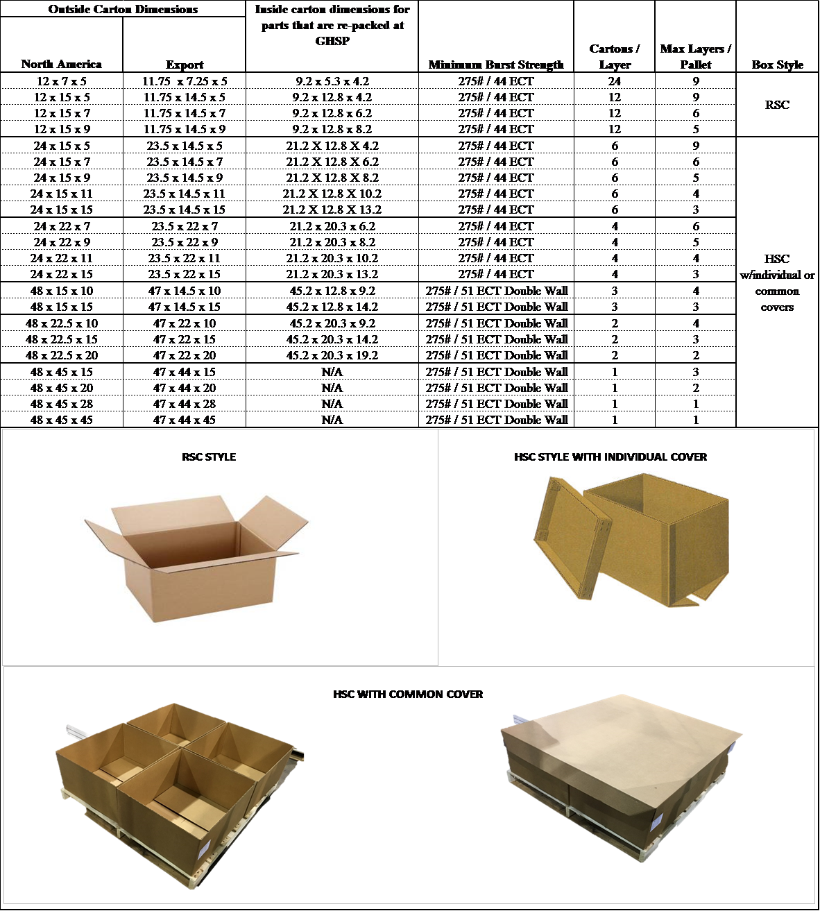
  - APPROVED CARTON SIZES

  - CARTON SELECTION PROCESS
    - The total Ergonomic Weight Limit for handheld cartons is 30 lbs. for North American shipments and 22 lbs. for shipments to China (total weight of carton, internal dunnage, and product combined).

    - Carton sizes must be selected from the GHSP approved carton sizes listed above. Any deviation in carton sizes must be approved by GHSP Packaging Engineering.

    - It’s the supplier’s responsibility to select the best sized carton when designing packaging for all components and assemblies. All factors must be taken into consideration when selecting the best carton footprint (i.e. maximizing carton space, part volume and usage, proposed assembly processes, overall carton weight, etc.). Suppliers are responsible for the design, development, testing, and validation of their packaging solutions.

  - EXPENDABLE CARTON CONSTRUCTION

    - All corrugate cartons shall be stamped with a manufacturer’s certificate in a visible location on the assembled carton. The stamp must specify Burst Test or ECT (Edge Crush Test) as shown:
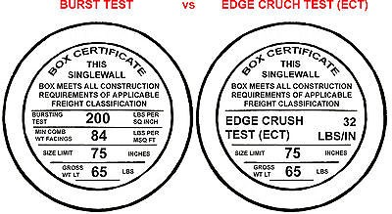

    - At minimum, single wall hand held cartons must be 44 ECT or 275-pound burst strength and be constructed of C-Flute linerboard. At minimum, double wall cartons must be 51 ECT or 275-pound and constructed of B-C linerboard.

    - Certain products and cartons may require stronger board strengths and it’s the supplier’s responsibility to select adequate packaging to support the intended distribution cycle.

    - All cartons shall be RSC (Regular Slotted Containers – attached closure flaps) or HSC (Half Slotted Containers – removable lid). Any deviations from an RSC or HSC carton must be reviewed and approved by GHSP Packaging Engineering. Smaller cartons shall be RSC (Regular Slotted Containers – attached closure flaps), larger boxes shall be HSC (Half Slotted Containers – removable lid). It is preferred that the lid be “Common” or one large lid for each layer of boxes on the pallet.

    - Corrugated cartons shall be designed to withstand temperatures ranging from
-30°F to +150°F and 90% humidity for a duration of 60+ days.

    - The preferred closure method of the carton’s manufacturer’s joint is to be glued. Staples are acceptable as long as there are no staples protruding from the carton material. Staples may also be used for the bottom of the carton but not to secure carton top flaps. For RSC cartons, the cartons top and bottom flaps shall be taped at all 6 locations where the flaps meet each other and the main carton body.

SECTION 3 – PALLETS

APPROVED PALLET DIMENSIONS

    - GHSP pallet dimensions have been determined based on the maximum utilization of North American truck trailers and International sea container shipments. The preferred pallet footprint for full utilization of shipments within North America is a 48” x 45” pallet. The preferred pallet footprint for full utilization of international shipments is a 47” x 44” pallet.

o Pallet size deviations may be allowed for suppliers whose shipping volumes do not fulfill full layers or full pallet loads, or whose product type requires specialized packaging.

    - Required Pallet Dimensions (OD – outside dimensions)

Palle t Footprint - preferred
North Ame rica | Inte rnational
48 x 45 | 47 x 44
Palle t Footprint - alte rnative
North Ame rica | Inte rnational
32 x 30 | 45 x 39
48 x 40

Note: A tolerance of +0”, -1/4” is allowed

PALLET MATERIALS AND CONSTRUCTION

Wood pallets and any wood packaging materials must meet ISPM 15 – Guidelines for Regulating Wood Packaging Material in International Trade and be stamped with the certified marking as shown:

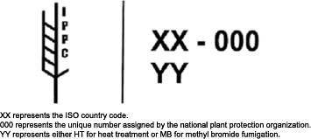

    - Shipments held in customs or any cost associated with re-packaging due to uncertified or non-compliant packaging will be billed back to the supplier.

    - Pallets must provide 4-way entry for maximizing material handling efficiency and be of double faced non-reversible hardwood construction.

    - Pallets must be of a Stringer or Full Perimeter Block design. Pallets other than hardwood stringer or full perimeter block construction must be approved by GHSP Packaging Engineering.
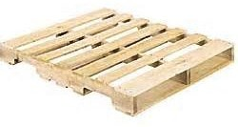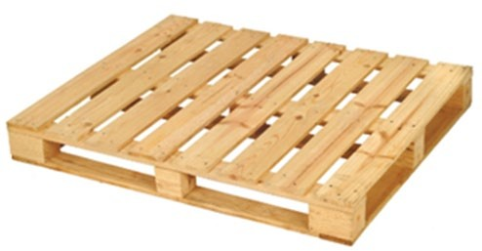
Stringer Pallet
Full Perimeter Block Pallet
    - Stringer pallets must have a minimum of a 3.5” fork height clearance on the primary side. The notched areas of the secondary sides must have a 2.5” minimum height clearance. Notches must be 9” long and have 18” centers. All pallets must have a minimum of three stringers.

    - Pallets must be constructed with cement coated nails or twisted nails flush to the surface or slightly recessed. Staples are NOT acceptable. Pallets must be strong enough to withstand 4,000 static pounds or the total weight of the dynamic load, whichever is larger.

    - Top deck boards must cover 60% of the actual surface area of the pallet footprint. Top deck boards must support each corner of each carton for maximum vertical support. This requirement provides adequate support for the bottom layer of cartons so they do not drop between the deck boards and cause failure of the entire pallet load or allow damage to the underside of the cartons due to hi-lo forks.

    - Packaging failure is often attributed to poorly constructed pallets. Do not use pallets with rotted or decayed lumber, knots, knotholes, bark, or splintered wood. Check for damage or splits in wood that will affect strength or interfere with nailing. Do not use substandard manufactured wood materials.

SECTION 4 – PALLETIZATION

GENERAL REQUIREMENTS

    - Each pallet must have material / product for one GHSP plant only. Mixed plant packaging is NOT allowed on the same pallet.

    - To maximize logistics capacity and minimize manual handling, full pallet loads should be shipped whenever possible. Ideal unit load heights should be 50” to maximize truck trailer capacity. Ideal unit load heights should be 44” to maximize standard sea container cube efficiency. Unit load heights must be compatible with current common shipping methods. Load height can be adjusted as needed to the maximum height of 50” when shipping via “High Cube” sea container.

STRETCH WRAP
    - The use of stretch wrap to secure the cartons to the pallet is preferred. All 4 corners of the pallet must be wrapped at least 3 times in order to fully secure the pallet load and minimize the shifting of cartons in transit.

    - Other factors such as material thickness, tension, and unit load weight must also be considered. Stretch wrap must have enough clarity to enable bar code scanning.

BANDING

    - If banding is used, the banding must be made of polypropylene or polyester (minimum 0.5” wide x 0.021” thick). Steel banding is NOT allowed for standard shipments. If metal banding is deemed necessary, it must be reviewed and approved by GHSP Packaging Engineering.

    - A minimum of two bands in the length and width (4 total) should be used for multiple containers on a pallet. Additional banding straps should be used if the cartons are not in a 2 x 2-layer arrangement on the pallet in order to secure each column of cartons on the pallet. Banding should be located clear of notched fork openings.

    - Fusing straps or crimp seals should be used to secure banding. The use of buckles is not allowed unless approved by GHSP Packaging Engineering.

UNITIZING OF CARTONS ON PALLET

    - Unit loads shall withstand a stacking height of 100” (2 full pallet loads high) in transit and have sufficient structural integrity to support normal handling and storage. Unit load integrity must also be maintained so pallet loads can be safely stacked in static (stationary storage) three pallet loads high or to a height of 12’ 6”, whichever is greater.

    - At least 2 opposite edges of each carton MUST be completely supported by the top deck boards of the pallet so that all 4 corners of the carton rest on a deck board. Cartons gain the majority of their stacking strength from their corners. Any carton that is suspended with less than two edges of the carton fully supported by the deck boards creates risk of dropping through the deck boards and causing the unit load to fail.

    - If the carton sizes used are not sufficiently supported on two opposite edges by the deck boards, a single layer of corrugate shall be used between the pallet and the bottom layer of cartons to prevent cartons from dropping between deck boards.
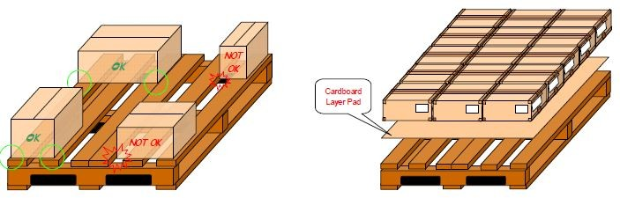

    - ALWAYS vertically stack cartons in a straight alignment (one carton directly on top of one another).
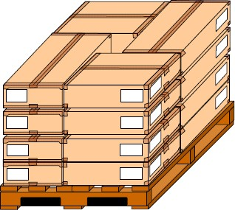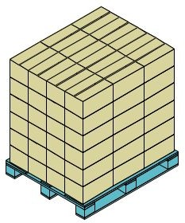

    - NEVER pyramid, interlock or brick stack cartons on a pallet.
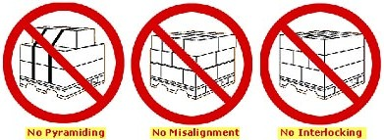

    - NEVER have carton overhang on a pallet. Overhanging cartons significantly reduces vertical stacking strength of the entire pallet load and causes crushing of cartons and the potential to damage parts.

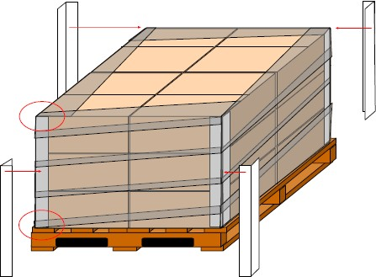
    - Laminated L-Shaped corner posts may be used externally on pallet loads to provide stability. Laminated corner posts are suggested for shipments of heavy parts and/or parts shipping long distances that are exposed to a dynamic shipping environment.

SECTION 5 – RETURNABLE PACKAGING

GENERAL REQUIREMENTS

    - Through agreement with GHSP, suppliers may at times utilize GHSP owned or supplier owned returnable packaging. GHSP Packaging Engineer will work with suppliers to determine container and dunnage requirements.

    - In order to accommodate container shortages, a sufficient supply of backup expendable packaging shall be maintained. Backup packaging shall simulate the returnable container and necessary dunnage while maintaining the same dimensions, function, and pack quantity while complying with GHSP expendable container requirements. It’s the supplier’s responsibility to make sure adequate backup packaging is available.

    - It is the supplier’s responsibility to remove old labels and inspect all containers for damage before use.

    - Supplier labels used on returnable packaging must be removable without the use of excessive force or cleaning agents.

    - Supplier owned packaging must have “Return to” labels or hot stamps located in a clearly visible area that does not interfere with the production identification labels.

SECTION 6 – MISCELLANEOUS

PV (PRODUCT VALIDATION) SHIPMENTS

    - Approved production intent packaging must be used for PV part shipments. Any deviations must be approved by GHSP Packaging Engineering.

DUNNAGE
- Fiberboard, plastics, bags or a combination of materials may be necessary to provide part protection and eliminate part damage due to shock and vibration incurred during the logistics cycle. Container loading, unloading, waste disposal, recycling, and any clean room requirements should be taken into consideration when developing internal dunnage.

CORROSION PREVENTION
- Parts that are susceptible to corrosion must be packaged with corrosion inhibiting materials such as VCI and/or desiccants. Parts designated for export should be given extra attention due to the greater risk of corrosion from longer transit times and extreme temperature and humidity fluctuations.

ESD PROTECTION
- The use of ant-static and/or ESD protective materials should be used for any sensitive electronic parts.

SECTION 7 – GHSP PACKAGING SKETCH FORM

COMPLETING AND SUBMITTING

    - After business is awarded and suppliers having adequate part data and/or sample parts, a preliminary GHSP “Packaging Sketch Form” must be submitted to GHSP Packaging Engineer for initial review. The GHSP “Packaging Sketch Form” can be downloaded from the GHSP website under the Supplier tab. It must be completed for the following instances:
      - New production parts
      - New supplier of a part
      - Change of part, packaging or shipping method
      - As deemed necessary

    - All fields within the Packaging Sketch Form must be filled out in their entirety and submitted to GHSP Packaging Engineer for review and approval.

    - The approved Packaging Sketch form must be submitted with PPAP documentation. Packaging changes after PPAP submission must be coordinated through GHSP Packaging Engineering and a revised Packaging Sketch Form must be submitted and approved.

SECTION 8 – LABELING

LABEL LOCATION

    - Each carton shall be labeled with 2 labels. Labels shall be located in the upper corners of adjacent length and width panels and be scannable with contact and non-contact devices from the exterior of the shipping unit.

LABEL ADHESIVE

    - Adhesives for expendable container labels shall be pressure sensitive. They must be able to withstand the complete distribution cycle of the package they are adhered to. Taping labels to a shipping unit is not acceptable. Card stock labels will be accepted as dictated by the application.

LABEL DESIGN

    - Label design shall be white in color with bold, black printing. All labels shall meet the AIAG specifications for quality, reflectivity, and readability.

LABEL CONTENT

    - Suppliers must ensure that all container labels used for GHSP product meet the following requirements:
    - Standard Label Size – Nominal dimensions of 4” high by 6.5” wide
- Box Titles [Field descriptor in top left corner of each box]
  - Font: Arial
  - Font style: Regular
  - Font size: 8

  - Alignment of Titles (Part, Qty, PO, Lot, MFG DATE, REV Level, Made In, Description, Supplier, Serial) to be 1/8” indented from left of box area and 1/16” indented from top of box area
- Part No. Field (P) [GHSP part number on PO & releases]
  - Font: Arial
  - Font style: Bold
  - Font size: 30
  - Alignment to be 1 ¼” indented from left of box area and 1/8” indented from bottom of box area

Part No. Barcode
  - Qualifier - P
  - Code 128
  - Height: .4”
  - Alignment to be 1/8” indented from left of box area and 1/16” indented from bottom of box area
- Qty Field (Q) [Physical quantity of parts in container]
  - Font: Arial
  - Font style: Bold
  - Font size: 20
  - Alignment is to be 1 ¼” indented from left of box area and 1/8” indented from top of box area

Qty Barcode
  - Qualifier - Q
  - Code 128
  - Height: .4”
  - Alignment is to be 1/8” indented from left of box area and 1/16” indented from bottom of box area
- PO Field (A) [GHSP PO number for part number]
  - Font: Arial
  - Font style: Bold
  - Font size: 20
  - Alignment is to be 1 ¼” indented from left of box area and 1/8” indented from top of box area

PO Barcode
  - Qualifier - A
  - Code 128
  - Height: .4”
  - Alignment is to be 1/8” indented from left of box area and 1/16” indented from bottom of box area

- Lot Field (1T) [Supplier ID number assigned to a single manufacturing run]
  - Font: Arial
  - Font style: Bold
  - Font size: 20*
  - Alignment is to be 1 ¼” indented from left of box area and 1/8” indented from top of box area
  - *If font size must be reduced to capture full Lot #, supplier must get approval from GHSP

Lot Barcode
  - Qualifier – 1T
  - Code 128
  - Height: .4”
  - Alignment is to be 1/8” indented from left of box area and 1/16” indented from top of box area
- MFG Date Field [Date parts were manufactured on]
  - Font: Arial
  - Font style: Bold
  - Font size: 20
  - Alignment is to be 1/8” indented from left of box and1/4” indented from top of box area
- Rev Level Field [Current revision of part based on active drawing]
  - Font is to be Arial
  - Font style is to be Bold
  - Font size is to be 20
  - Alignment is to be 1/8” indented from left of box area and 1/4” indented from top of box area
- Made-In Field [2-digit country code where parts were manufactured]
  - Font: Arial
  - Font style: Bold
  - Font size: 20
  - Alignment is to be 1/8” indented from left of box area and 1/4” indented from top of box area
- Description Field [Description of part located on GHSP PO & releases]
  - Font: Arial
  - Font style: Bold
  - Font size: 20
  - Alignment is to be 1/8” indented from left of box area and 3/8” indented from top of box area

- Supplier Field [Supplier name & number based on GHSP PO & releases]
  - Font: Arial
  - Font style: Bold
  - Font size: 20
  - Supplier Name to be 1/8” indented from left of box area and 1/4” indented from top of box area
  - Supplier Number is to be 1/8” indented from left of box area and 1/2” indented from top of box area
- Serial Field (S) [Supplier unique number assigned to a single container of parts]
  - Font: Arial
  - Font style: Bold
  - Font size: 20
  - Alignment is to be 1” indented from left of box area and 1/8” indented from top of box area

Serial Barcode
  - Qualifier - S
  - Code 128
  - Height: .4”
  - Alignment is to be 1/8” indented from left of box area and 1/16” indented from bottom of box area

PDF-417 Barcode
  - Information MUST include Part No, Qty, Supplier Name and Lot No. in 2D barcode
  - PDF417
  - Encoding: US, Western Europe (ANSI,1252)
  - Alignment is to be 1/2” indented from left of box area
  - Data Feed
- Begin with [) (2 characters, [=bracket,) = right parenthesis)
- Apply Record Separator (non-human readable character)
- Apply Group Separator for every dataset (non-human readable character)
- Apply dataset with prefix (i.e. Part No = P10868731)
- Once complete, apply Record Separator and apply End of Transaction (non-human readable character)
- Example of what a scan looks like:

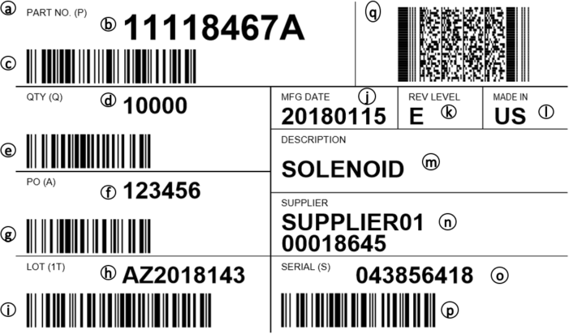

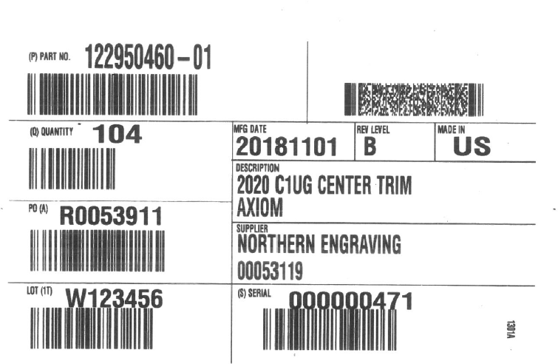
Example label in new GHSP part number format:

  - MIXED PALLET LOADS
    - If orders dictate less than full pallet loads, cartons should be palletized in full layers whenever possible. When carton quantities are insufficient to complete one full layer, additional cartons of differing part numbers should be consolidated onto a mixed load pallet.

o NOTE: When shipping mixed load pallets, cartons of the same part number should be VERTICALLY stacked together within the pallet.

    - A MIXED load label must be used to identify a load of multiple single cartons of different part numbers. The Mixed load label must appear on two adjacent sides of the pallet load where it can be easily seen (on outside of stretch wrap or unobstructed from banding straps).
    - For a mixed load pallet, a MASTER label is required. Master labels must detail all part numbers and their quantities and be placed where it can be easily scanned (on outside of stretch wrap or unobstructed from banding straps).
    - All containers must have the final GHSP destination information affixed either as a master label on the skid or within the standard label format affixed to each carton. Data required includes GHSP site name, address, city, state and postal code.
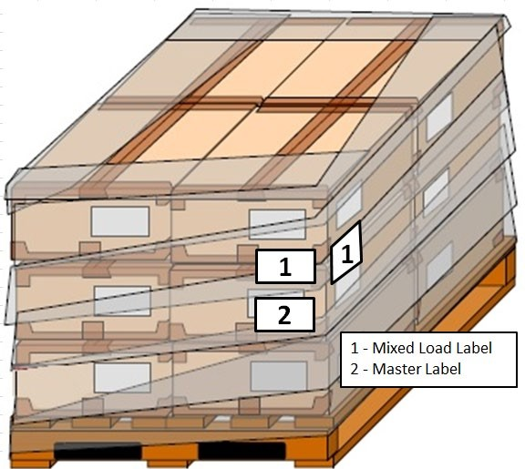

Additional Shipment Labels

    - All shipments sent for PPAP approval must have yellow PPAP Sample stop signs attached to all four sides of the skid (see appendix 11.1).

    - This sign should include the GHSP contact to whom you are submitting the PPAP and a general description of the PPAP submission.
    - All Plant Trial shipments must have orange Line Trial stop signs attached to all four sides of the skid (see appendix 11.2).
    - This sign should include the GHSP Contact that is coordinating the trial, the PO # that the material is shipping against, and a general description of the plant trial intent for the product.
    - When shipping the first shipment after the PPAP has been approved, this includes part number changes, part revision changes, and all Engineering changes please attach the green First Shipment sign on all four sides of the skid (see appendix 11.3). This sign should include the GHSP Materials contact at the facility to whom you are shipping and description of the shipment.
    - All consignment parts shipping into the plant must have a BLUE Consignment stop sign label attached to all four sides of the skid. The label should be marked “CONSIGNMENT - IN PLANT STORE MATERIAL” (see appendix 11.4).
    - All shipments and sample product that is NOT PPAP approved must have a RED “NON PPAP APPROVED” stop sign attached to all 4 sides of a skid or minimum 2 sides of individual cartons (see appendix 11.5). Include the GHSP contact to whom these parts are shipping and a general description of the product.

Special labeling requirements for components assembled in GHSP clean rooms
    - Certain components will have special labeling requirements when they’re assembled in GHSP clean rooms. The box, and in some cases the tote cannot enter the clean room and must be re-packed internally at GHSP. To keep component traceability throughout the process, GHSP will require a “Loose shipping label” (backing to remain on the label so it will not stick to anything) be placed in the box/tote the components ship in. That way, the label can stay with the components after they’re re-packed. Please contact your GHSP Packaging Engineer to understand if this requirement will apply to your parts.
    - This requirement is in addition to the outside container label per 8.1.
    - Example photos:

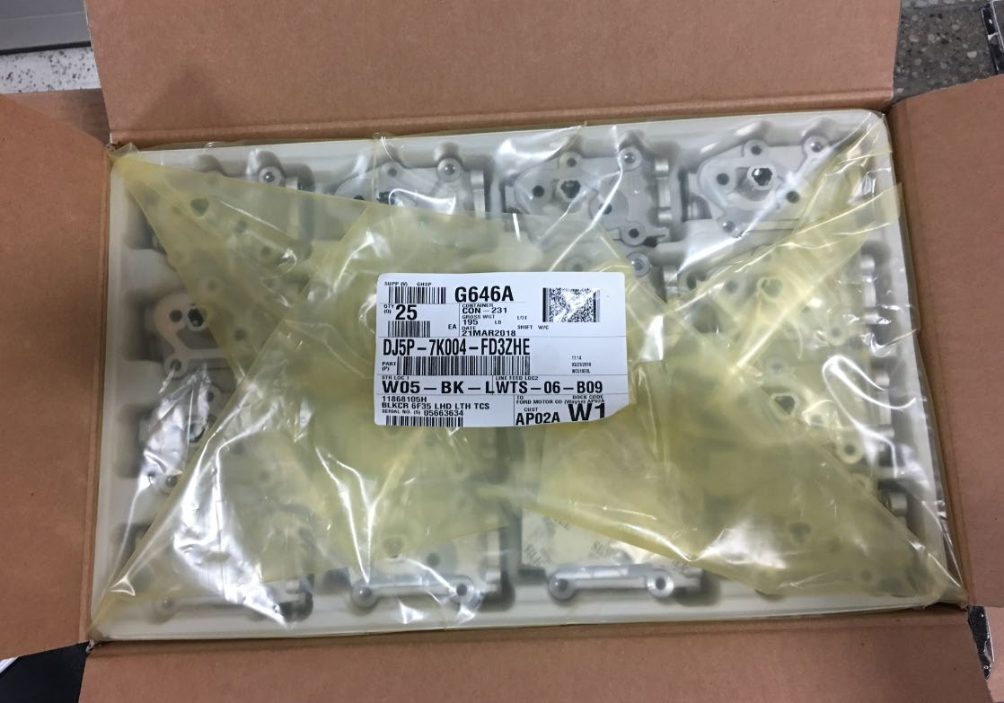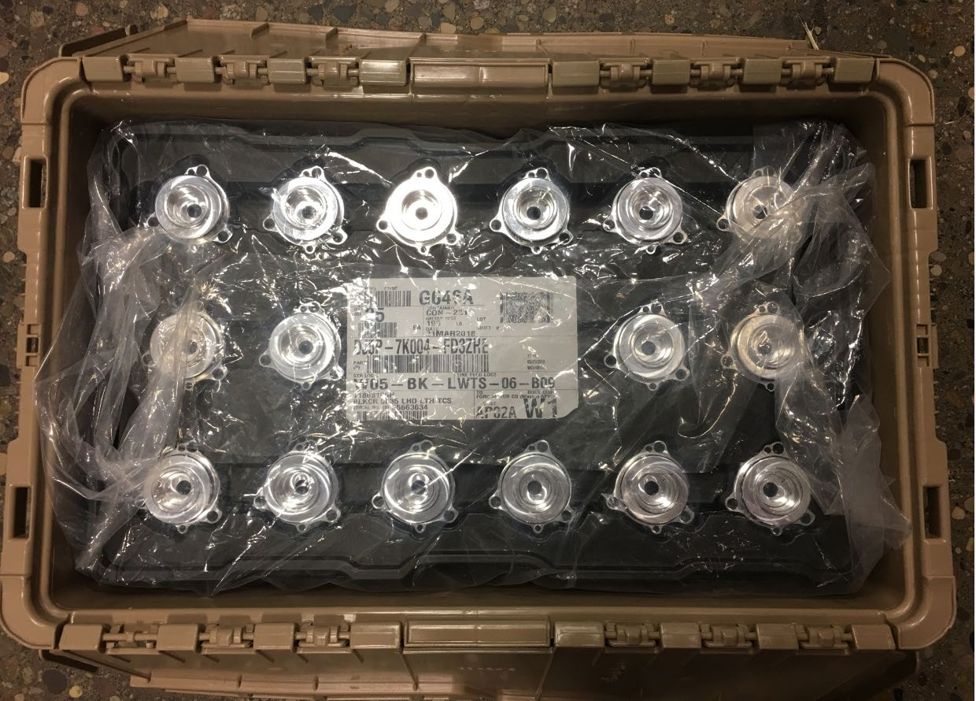
LABEL IN BAG
LABEL IN BAG
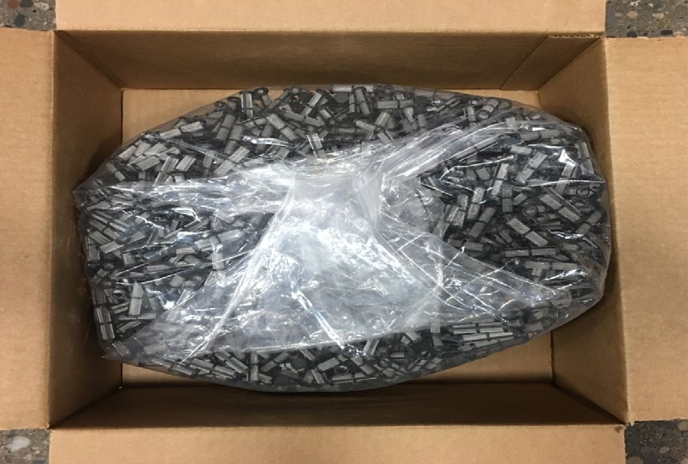
LABEL IN BAG

SECTION 9 – ENVIRONMENTAL
- GHSP is committed to being an active member of the corporate community by setting an example for environmental protection and preservation. Packaging materials used by suppliers affect the environment in multiple ways from the manufacturing of the material to end use. GHSP supports the manufacturing of materials that permit reuse or recovery in the form of recycling, composting of biodegradable material, and energy recovery. Therefore, suppliers should target materials that adhere to the following:
  - Ability to be reused or recycled
  - Made from a renewable resource
  - Provide limited impact on the environment during manufacturing and end of life

SECTION 10 – PACKAGING QUESTIONS
- Packaging questions or issues should be communicated to GHSP Packaging Engineering. Ask your buyer for the proper Packaging Engineering contact information.

SECTION 11 – LABEL APPENDIX
- 11.1 – PPAP SAMPLES

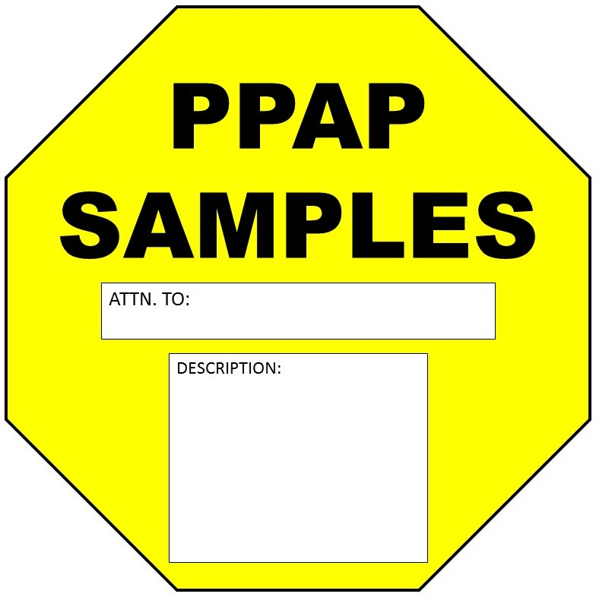

- 11.2 – LINE TRIALS

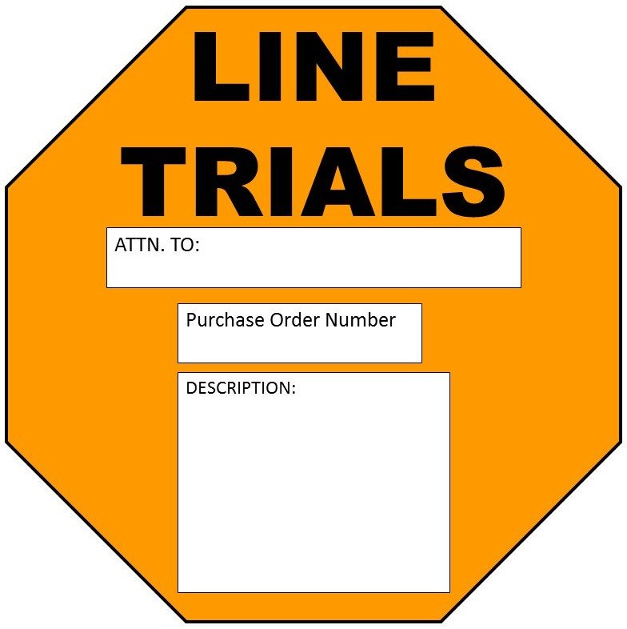

- 11.3 – FIRST SHIPMENT

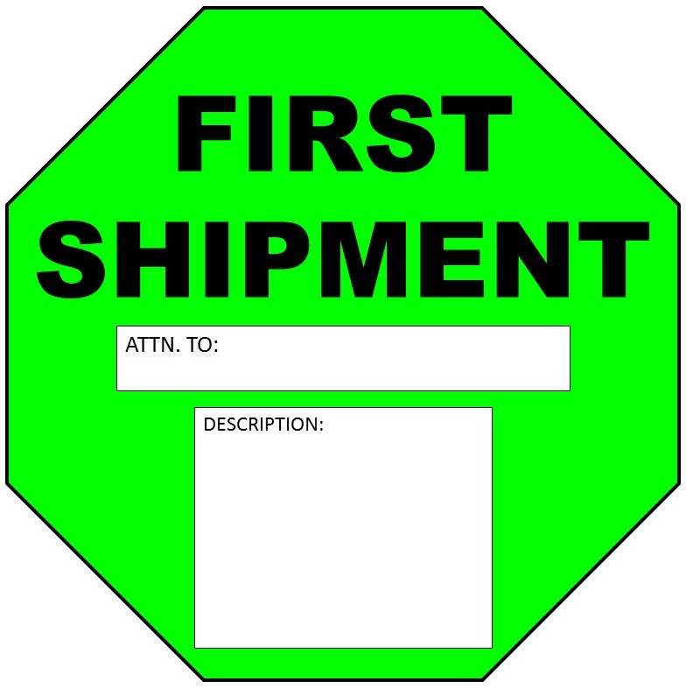

- 11.4 – CONSIGNMENT

- 11.5 – NON PPAP APPROVED

