October 27, 2020

Important Supplier Notification Regarding Mexico NOM Requirement

Dear Supplier,

Effective on October 1st, 2020 the Mexican Regulation on Packaging and Labeling changed. The official Mexican list of standards and regulations NOM-050-SCFI-2004 provides information regarding the general labeling of products. Labels must be readable and contain manufacturer’s name, importer’s name, description of its components (as defined by the Harmonized Tariff Schedule) and must be in Spanish. No requirements as to the size of label and font size.
This additional label does not affect any current GHSP Label requirements as put forth in our supplier terms and conditions, GHSP’s suppliers are responsible for providing timely and accurate adherence to the Mexican Regulation. Your compliance allows GHSP, in turn, to satisfy the import requirements without further delaying the transit and additional cost of relabeling meet the requirements of our customers as well as minimizing duty expenditures.
Each box must be labeled according following details:
LABEL information:
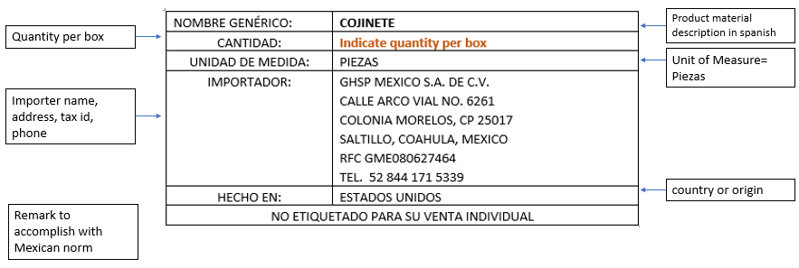

Sample of Label Placement:
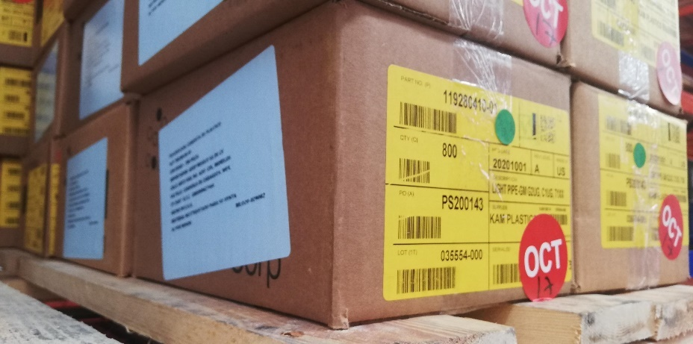

Your compliance in meeting the Labeling requirements is vital and your support is much appreciated. Some helpful links are listed below. Please refer any questions to GargusT@GHSP.com.
National Standards Organizations –
https://www.gob.mx/se/acciones-y-programas/competitividad-y-normatividad-normalizacion
Mexico – Labeling /Marking Requirement –
https://www.export.gov/apex/article2?id=Mexico-Labeling-Marking-Requirements

Kind Regards,

Victoria Satterlee
Manager of Trade Compliance and Logistics

