Subject: GHSP Control Devices Integration Update – Phase 1 Successfully Completed

Dear Valued Supplier Partner,

On behalf of the leadership teams at GHSP and GHSP Control Devices, we would like to share an important update on the ongoing integration of the former Stoneridge Control Devices business into the GHSP organization.
First and foremost, thank you for your continued partnership, support, and collaboration throughout this transition. Your commitment has played an important role in helping us successfully complete the first phase of our integration journey.
We are pleased to announce that Phase 1 of the Procurement and Supply Chain Management (SCM) integration is complete.
Since Center Rock Capital Partners acquired the former Stoneridge Control Devices business on February 1, 2026, our primary objective has been to protect operations and ensure the integration process does not disrupt production, customer deliveries, supplier relationships, or overall business continuity.
This phase focused on maintaining uninterrupted procurement, supply chain, logistics, and supplier management activities while establishing the foundation for a fully integrated organization.
We are also pleased to report on the successful transition from the Transfer Service Agreement (TSA) environment that supported the initial separation from Stoneridge. As a result, all former Stoneridge Control Devices operations are now aligned under the GHSP family of companies and operating as:

GHSP Control Devices, Inc.
A Subsidiary of GHSP, Inc.

To support this next stage of growth, a fully integrated Procurement and Supply Chain Management organization is now in place and supports all GHSP, Inc., and GHSP Control Devices, Inc., locations globally.
For reference, see Attachment 1A – Global Procurement & Supply Chain Management Organization and Attachment 1B – GHSP Global Procurement & Supply Chain – Commodity Responsible & Escalation Points, which outline the integrated Procurement & SCM structure and the key leadership responsibilities supporting our global operations.
The integrated Global Procurement & SCM organization will operate under the leadership of:

Ludwing Vergara
Vice President of Procurement & Supply Chain Management
To support our China-for-China operating strategy and maintain responsiveness to local market requirements, Procurement and SCM operations within China will continue under the leadership of:

Reyn Sun
Director of China Operations
The China organization will maintain direct responsibility for local procurement and supply chain activities while remaining closely aligned with the Global Procurement & SCM organization.
Most importantly, suppliers do not need to take any action at this time. Existing contracts, purchase orders, commercial agreements, supplier nominations, sourcing awards, and operating processes remain unchanged and remain fully valid.
We remain committed to maintaining transparent communication and strong supplier partnerships as we continue our integration journey.
Thank you for your continued support and partnership. Sincerely,

Ludwing Vergara
Vice President, Procurement & Supply Chain Management GHSP, Inc.

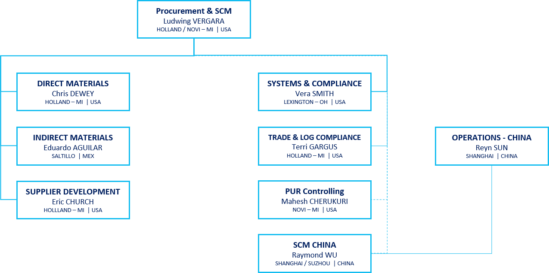
Attachment 1A | GHSP Global Procurement & Supply Chain Organization

Attachment 1B | GHSP Global Procurement & Supply Chain – Commodity Responsible & Escalation Points
