- Revision Log

Revision Log
Revision Level | Revision Date | Section | Description |  | Revised By
REL | 5-18-2020 | ---- | Initial Release |  | TPC
A | 12/1/23 | Header | Replaced GHSP logo with newer version |  | B. Balok
Approval: |  | CN: RS,FS |  | MX: JH
 |  | US: JA |  | Other (as req’d): DRW

- Purpose:
  - To define the global standard for the use of Cleaning Methods for inprocess product cleaning and air filtration/extraxtion.

- Scope:
  - This global standard applies to all GHSP manufacturing facilities.

- Definitions:
  - Part Cleaning
    - Ionized Air
    - CO2/Blown Ion
    - Plasma
    - Filtration

- References:
  - CP-WI-MFG-X301 Global Standard Production Equipment Safety, Ergonomic, and Delivery Checklist
  - CP-WI-MFG-X327-Global Standard Assembly Equipment Manual
  - Job Aids (Operating Standards Job Aids 8.5-Job-Aids-prod-service Global Standards)
  - ISO 16232-10 Cleanliness Code Test “E”

- Method:
  - Cleaning Equipment
    - Preferred Brands
Selection outside the preferred brand requires approval by the Advanced Process Engineer and Global Standards Team
- CO2 Cleaning
  - Cool Clean CO2
  - CleanLogix
- Plasma treating/Blown Ion
  - Plasmatreat
  - Enercon Industries Corperation
    - Start Up best practice
      - Gap nozzle to surface 3/8” +/- ¼”
      - Speed 50fpm or faster
- Ionized Air Knife
  - Nex Flow
- Air Filtration/Extraction
  - Bofa - Fumes
  - Purex – Laser dust

    - PLC Communication
Selection outside the preferred method requires approval by the Advanced Process Engineer and Global Standards Team
- EtherNet/IP
- Serial
- Discrete I/O

  - Verification
    - Tin foil Coverage verification (example 6.1.1-6.1.2)
    - ISO test Partical extraction
    - Gravimetric
    - Filtrex partical counter
    - Dyne Pen
    - Suface Analyzer
      - Kruss (brand)

  - Audible Alert

- Records:
  - Tin foil test for CO2 cleaning coverage. (save in Sharepoint program file: Documents/Manufacturing/Advanced Procesing/Deliverable)
    - Poor
      - 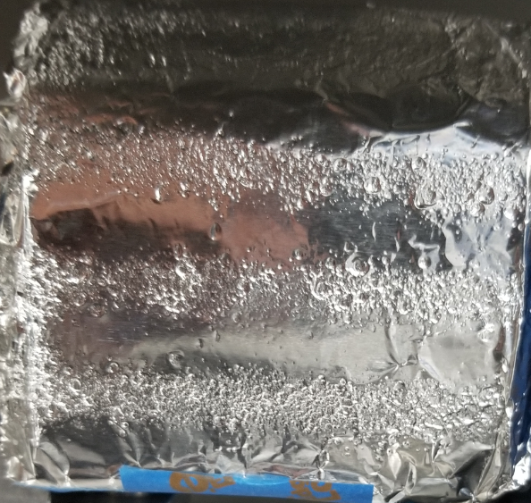
    - Good
      - 