- Revision Log

Revision Log
Revision Level | Revision Date | Section | Description |  | Revised By
REL | 2/14/2019 | ---- | Initial Release |  | BP
A | 12/1/23 | Header | Replaced GHSP logo with newer version |  | B. Balok
Approval: |  | CN: RS | MX: JH
 |  |  |  | US: NT | Other (as req’d):

- Purpose:
  - To define the global standard for internal strain gauge requirements.

- Scope:
  - This global standard applies to all GHSP manufacturing facilities with a PCBA and the manufacture of PCBA.
  - Specific customer requirements are defined in the product statement of work.
- Definitions:
  - SMT -Surface Mount Technology
  - PCBA - Printed Circuit Board Assembly
  - ICT - In-Circuit Test
  - Router -Method to cut PCBA from a panel of multiple PCBA’s
  - FT - Final Test
  - JEDEC - Joint Electron Device Engineering Council
  - ASTM - American Society for Testing and Materials
  - WBS - Work Breakdown Schedule
  - PDP - Product Development Process
  - MS - Micro Strain
    - Dimensionless unit, 10⁶ X (change in length / (original length).

- References:
  - IPC/JEDEC-9704A 2012 – February
    - Printed Circuit Assembly Strain Gauge Test Guideline
  - PD-WI-MFG-205-MRR
  - PDP

- Strain Measurement Equipment.
  - Strain Gauge Equipment Selection
    - Preferred Brand, Micro Measurements 9000 - 16-SM
- Order Rosettes and Connectors through Vishay Measurements Group
  - Rosettes – MMF 315462 - C2A-13-031WW-350 STACKED ROSETTE.
  - RJ45 Connector (MM12X70)0225 “3X per rosettes”

- Strain Metric:
  - Strain measurement unit measure is MS (Micro Strain).
  - Strain level measurement, during process steps (ICT, Router, FT, Assembly into finished goods, EOLT but not limited to.)
  - the strain metric should be the one that was used to derive strain guidance (such as in IPC/JEDEC-9707).

- Data Analysis:
    - Strain gauge process steps should be based on actual production work practices and or for gathering problem solving data.
    - Good judgement must be exercised to ensure the simulations are representative of normal and or worst-case strain profile measurements.

- Maximum strain industry standard:
    - According to KEMET - Ceramic chip capacitor flex can cause cracks (by Jim Bergenthal)
    - Failure in ceramic capacitor appear to occur when strain values are 1,300-2,500MS or higher.
    - Recommended to not exceeding highest value Kemet specification, 2,500 MS
    - The GHSP global standard recommends not to exceed 1000um/m Micro Strain value and is typically consider by several board Manufactures as internal specification. It is recommended a minimum of 2-3 repeatable strain values for strain gauge validation analysis.

Responsibility:
The Director of Manufacturing and Central Services is responsible for Strain Gauge services. The validation shall be performed by a well-trained advanced process engineer or designate, to insure the validity of the test and protection of the equipment.

The Program Managers (PM) are responsible for monitoring the progress of
programs within their business units and direct resources to ensure that all launch programs meet GHSP and customer requirements. The Advanced Process engineer and Program manager will budget enough funds to perform strain gauge analysis including the purchase of Rosettes for all programs and assembly equipment analysis.

- Strain Analysis is performed;
    - Phase 3 Design Verification prior to shipping equipment to the production floor and equipment buy off.
    - Phase 4 Manufacturing Readiness Review Prior to Production Validation.

  - PDP template “WBS numbers template will change”
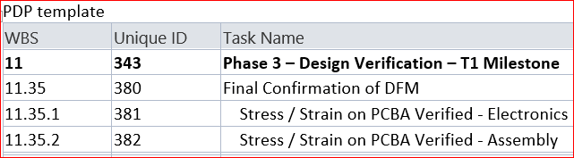
  - 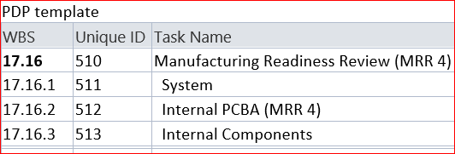
  - When mating component dimensions change effecting the PCBA.
  - When process parameters are changed, that may affect the PCBA.
    - Example; An assembly press
  - If new equipment or when equipment is modified effecting the PCBA.
  - When a PM schedule is setup for Strain Gauge analysis confirmation.
- Micro Strain Reduction:
Reduce micro strain values to less than 1,000ms by changing product design, handling, fixturing and process parameters to achieve the least amount of strain on the PCBA.
- Report Summary:
The validation report must have, the strain gauge graph pictures and call out the maximum strain for final compliant confirmation. The validation report will be saved by the owner and provided to the program team so they can share it with our customer if required.
Define; Share Point program manufacturing folder
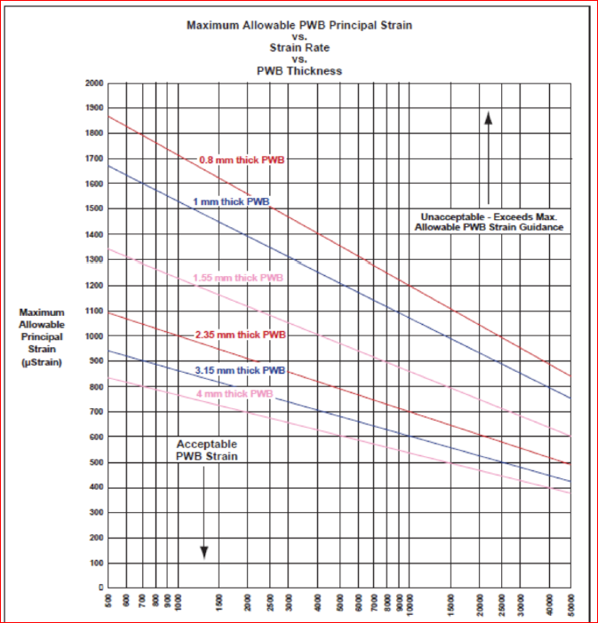
13.0 PWB principal strain table for reference:

