1. **Revision Log**

|  |  |  |  |  |  |
| --- | --- | --- | --- | --- | --- |
| Revision Log | | | | | |
| Revision Level | Revision Date | Section | Description | | Revised By |
| REL | 11/29/18 | ---- | Initial Release | | NT |
| A | 3/27/20 | Title  4.0 | Changed Autonomous Intelligent Vehicles to Autonomous Mobile Robot  Added 4.3 as a reference | | NT |
| B | 12/1/23 | Header | Replaced GHSP logo with newer version | | B. Balok |
|  |  |  |  | |  |
|  |  |  |  | |  |
|  |  |  |  | |  |
|  |  |  |  | |  |
|  |  |  |  | |  |
|  |  |  |  | |  |
| Approval: | | CN: RS,FS | | MX: JH | |
| US: JA | | Other (as req’d): DRW | |

1. **Purpose:** 
   1. To define the global standard for the use of Autonomous Mobile Robot (AMR) within GHSP manufacturing facilities.
2. **Scope:** 
   1. This global standard applies to all GHSP manufacturing facilities.
3. **Definitions:** N/A
4. **References:**
   1. ISO 10218-1, 2:2011 Industrial Robot Safety Standards
   2. ANSI/RIA R15.08 Industrial Mobile Robot Safety
   3. ISO 3691-4:2020 Industrial Trucks-Safety Requirements and Verification-Part 4: Driverless Industrial Trucks and Their Systems
   4. MiR User Guide
5. **Method:**
   1. **Autonomous Mobile Robot Selection**
      1. Preferred Brands

*Selection outside the preferred brand requires approval by the Advanced Process Engineer and Global Standards Team*

* Mobile Industrial Robots (MiR)
  + If using only 1 MiR, Call Boxes will be needed at each docking point/station.
  + If using 2 or more, MiRFleet Software required.
    - MiRFleet Software will have wireless and server requirements. These requirements will have to be reviewed with JSJ prior to bringing the AMR’s into the plant.
  1. **Requirements**
     1. VL Marker
        + A VL Marker (see picture below) must be used at every docking point/station.
        + If needed, contact the Machine Build Group and let them know the quantity needed.

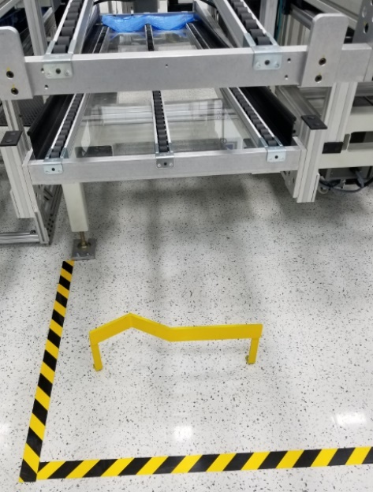

* + 1. Light Indicators
       - The AMR will use the default light indicator scheme (see picture below) to indicate current operational state.

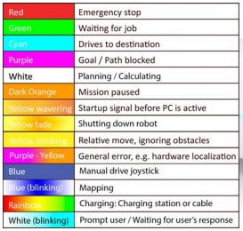

* + 1. Sound
       - AMR must use the default “Beep” sound before moving, to make personnel nearby aware that it is about to move.
  1. **Guidelines**
     1. Accessories
        + Auto Roller Conveyor
        + Auto Roller Conveyor with Lift
        + Lift
        + Tow Hook
        + Cobot

1. **Records:** N/A