|  |  |  |  |  |  |
| --- | --- | --- | --- | --- | --- |
| Revision Log | | | | | |
| Revision Level | Revision Date | Section | Description | | Revised By |
| REL | 5/8/2017 | ----- | Release | | JY |
| A | 9/11/2017 | 5.1.3 | All new Stations Should use Digital Gauges control by PLC and display in HMI | | JY |
| B | 11/21/19 |  | Mass updates, complete re-write to standard | | NT |
| C | 7/7/21 | 5.6 | Added pictures and tables for Standard Safety Air Preps | | NT |
| D | 3/17/22 | 5.6 | Updated pictures and table for Standard Air Preps | | N. Taylor |
| E | 9/19/22 | 5.2 | Added 5.2.2 | | N. Taylor |
| F | 12/1/23 | Header | Replaced GHSP logo with newer version | | B. Balok |
|  |  |  |  | |  |
|  |  |  |  | |  |
| Approval: | | CN: RS | | MX: BA | |
| US: JA | | Other (as req’d): | |

1. **Purpose:**

**0.1** To define the global standard for the use of Pneumatics within GHSP manufacturing facilities.

1. **Scope:** 
   1. This global standard applies to all GHSP manufacturing facilities.
2. **Definitions:** 
   1. ASME – American Society of Mechanical Engineers
      1. A professional association that promotes the art, science, and practice of multidisciplinary engineering and allied sciences around the globe.
   2. ANSI – American National Standards Institute
      1. A private non-profit organization that oversees the development of voluntary consensus standards for products, services, processes, systems, and personnel in the United States.
   3. [OSHA](https://www.osha.gov/SLTC/robotics/) – Occupation Safety and Health Administration
      1. An agency of the United States Department of Labor, whose mission is to assure safe and healthy working conditions for people by setting and enforcing standards.
   4. PO Check Valve – Pilot Operated Check Valve
3. **References:**
   1. CP-WI-MFG-X301 Global Standard Production Equipment Safety, Ergonomic, and Delivery Checklist
4. **Method:**
   1. **Pneumatic Equipment Selection**
      1. Preferred Brands

*Selection outside the preferred brand requires approval by the Advanced Process Engineer and Global Standards Team*

* + - 1. SMC
      2. Schunk
      3. Bimba
      4. PHD
    1. Vertical Applications
       1. Open center valves shall be used
          1. If you cannot or choose not to use an open center valve, you must get approval from the Plant Technical Services Manager
          2. If approved, a different series valve (i.e. VQC5000 vs VQC2000) must be used so that there is no chance a non-open center valve can replace an open center valve (or can be installed in place of an open center valve)
       2. PO check valves shall be used
       3. Cylinder rod locks shall be used
    2. Horizontal Applications
       1. Open center valves shall be used
    3. Rotating Clamp or Swing Clamp style of pneumatic cylinders are **not allowed.**
    4. PO Check Valve Requirements
       1. PO check valve shall include air bleed valve
       2. PO check valve shall be directly mounted on the cylinder
       3. PO check valve flow lines shall be black
  1. **Valve Selection**
     1. Preferred Brands

*Selection outside the preferred brand requires approval by the Advanced Process Engineer and Global Standards Team*

* + - 1. SMC
      2. ROSS
    1. “S” valve blocks shall NEVER be used

* + 1. All valves must be labelled to identify function, advance & return, and address. Example:

……………………………….

Advance >>

SMC:0.D[1].0

Nest 2 VAC CUP CYL

<<< Return

SMC:0.D[1].1

………………………………..

Advance >>

SMC:0.D[1].2

Nest 2 BOOT INV SIDE

<<< Return

SMC:0.D[1].3

……………………………………

* 1. **Pressure Gauges**
     1. Need to be located so that they have a clear line of sight to the readings.
     2. All digital gauges need to be analog and have the set points controlled and monitored by the PLC and displayed on the HMI.
  2. **Surge Tanks**
     1. If an air surge tank is required, the tank must be equipped with pressure relief devices, a digital pressure gauge, include an air fuse after the tank, and must comply with ASME certifications.
     2. Must exhaust with lockout devices to remove stored energy.
  3. **Pressure Relief Valve**
     1. Pneumatic systems must include a pressure relief valve set to the lowest rated component in the system not protected by a pressure regulator.
  4. **Air Line Requirements**
     1. Color code:
        1. North America
           1. Red: Working flow lines
           2. Blue: Return lines to valves and other devices
        2. China
           1. Blue: Working flow lines
           2. Black: Return lines to valves and other devices
     2. Machine pneumatic system to be sized according to CFM calculation requirements.
        1. Machines to run at 65psi
        2. CFM calculations to be provided by supplier
        3. Reference air circuit diagram below
     3. An air fuse must be included on the plant supply line to the machine.
     4. Pneumatic flexible lines must be protected from damage (i.e. rubbing or chafing).

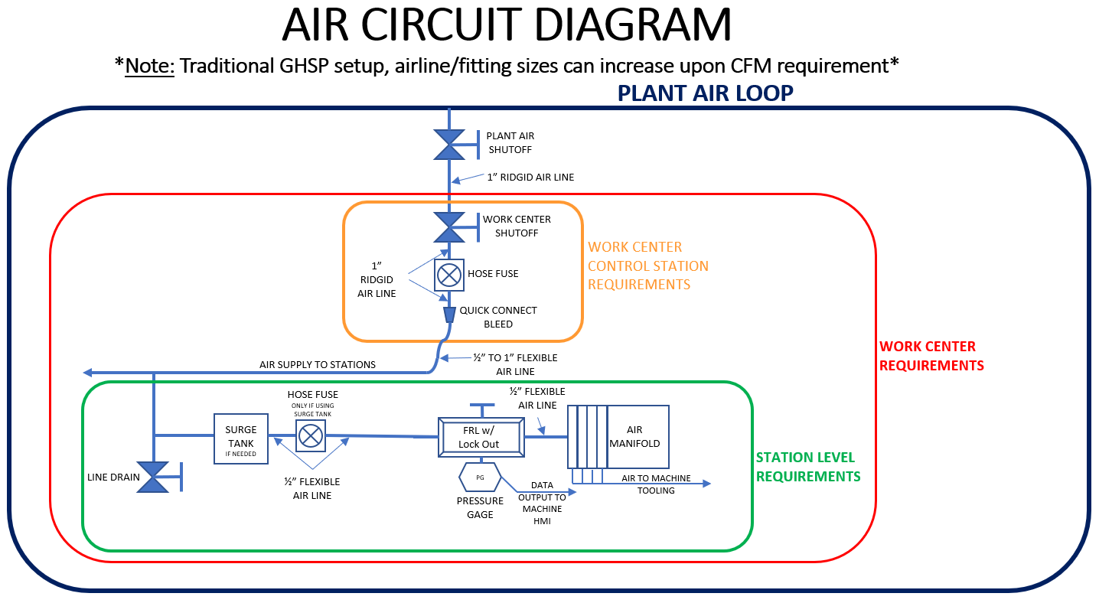

**Standard North America Safety Air Prep**

**SMC Electric Air Dump, Slow Start, Filter, Regulator**

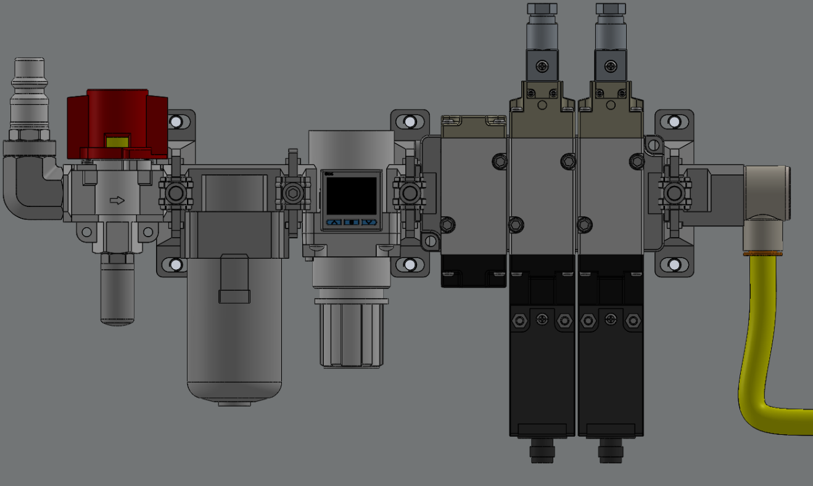

11 (x2)

*behind valves

13

9

12

7

8

6

4

3

3

3

2

1

10

5

|  |  |  |  |
| --- | --- | --- | --- |
| **Item** | **Part Number** | **Description** | **Qty** |
| 1 | VHS30-N03B-Z | SMC 3-PORT LOCKOUT HAND VALVE | 1 |
| 2 | AN20-N02 | SMC SILENCER | 1 |
| 3 | Y300T-A | SMC SPACER ATTACHMENT | 3 |
| 4 | AF30-N03-Z-A | SMC PNEUMATIC FILTER | 1 |
| 5 | Y300-A | SMC SPACER ATTACHMENT | 1 |
| 6 | VP544-5DZ1-03N-M-X555 | SMC RESIDUAL PRESSURE RELEASE VALVE | 1 |
| 7 | AR30K-N03-Z-B | SMC PNEUMATIC REGULATOR | 1 |
| 8 | ISE20A-V-N01-J | SMC DIGITAL PRESSURE SENSOR | 1 |
| 9 | KQ2VS13-36NS | SMC PNEUMATIC PUSH LOCK FITTING | 1 |
| 10 | 6534K42 (*or other compatible part number) | QUICK DISCONNECT HOSE COUPLING | 1 |
| 11 | AN30-N03 | SMC SILENCER | 2 |
| 12 | E300-N03-A | SMC PIPING ADAPTER | 1 |
| 13 | 5232T131 (*or other compatible part number) | 90-Degree Elbow Air Adapter | 1 |

**Standard China Safety Air Prep**

**SMC Electric Air Dump, Slow Start, Filter, Regulator**

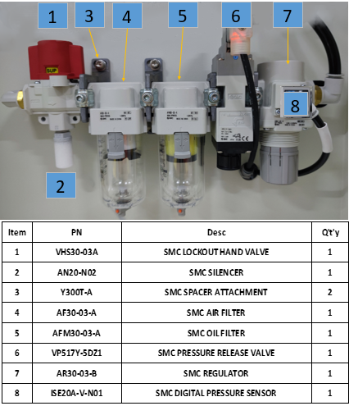

1. **Records:** N/A