- Revision Log

Revision Log
Revision Level | Revision Date | Section | Description |  | Revised By
REL | 03/23/2017 | ---- | Initial Release |  | MJG
A | 05/05/2017 | 6.0 | Added Audit questions to document |  | MJG
B | 09/24/2019 |  | Mass updates, complete re-write to standard |  | NT
c | 01/15/2019 | ---- | Revised to change title consolidate and add transfer and palletized conveyor systems |  | MJG
D | 10/7/2020 | 5.1.9 | Add to the available options the Rotating Pallet Cart |  | DM
E | 12/1/23 | Header | Replaced GHSP logo with newer version |  | B. Balok
Approval: |  | CN: RS, FS |  | MX: JH
 |  | US: JA |  | Other (as req’d): DRW

- Purpose:
  - To define the global production standard for the selection, setup and implementation with regards to manual or automated conveyor use within GHSP manufacturing facilities. Conveyors provide the ability for manual or automated handling of products throughout the GHSP manufacturing process. Conveyor usage can support improved efficiency, Standardize process flow, improved product quality, improved ergonomic conditions ,and reduced product cost .

- Scope:
  - This global standard applies to all GHSP manufacturing facilities.

- Definitions:
  - Transfer Conveyor
    - Automated belt or track conveyor used to move parts from station to station.

  - Palletized Conveyor System
    - Automated conveyor system use to transfer assembly pallets from station to station within an assembly process. High precision positioning is possible for automated assembly usage.

  - Gravity Roller Conveyor
    - System of roller structures that are used to move product from point to point with ease. Often utilized to handle large or bulky products that would otherwise be unsafe to be handled manually.

  - Tilt Table
    - A hydraulic, Air or Electric driven equipment used to improve ergonomic orientation to access.

  - EOL – End of Line

  - Ergonomics
    - The study of human efficiency in their work environment.

  - Abduction (Re: Abducted Pull)
    - Movement of a limb away from the body’s midline axis, such as elevating the elbow or raising the arm to the side

- References:
  - CP-WI-MFG-X301 Global Standard Production Equipment Safety, Ergonomic, and Delivery Checklist

- Method:
  - Conveyor selection to be determined based on application and or precision requirement including the following:
    - Roller Type Conveyor – Shall be utilized as manual or intermediate automation for movement of materials or customer finished good packaging in, between or at end of manufacturing process steps. Shall be compatible with application and meet requirements of package or material size and handling requirements.
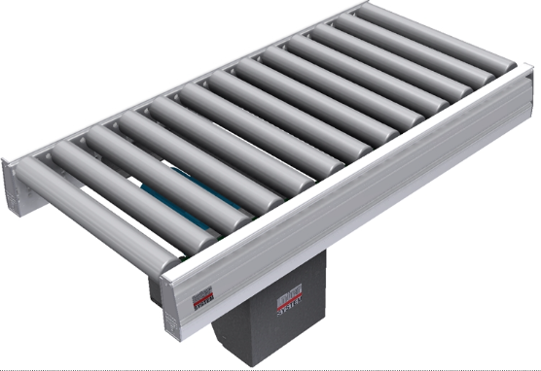
Example Image

    - Belt Type Conveyor – Shall be utilized as intermediate or high automation for movement of materials or customer finished goods in, between or at end of manufacturing process steps. Shall be compatible with application (Example ESD, Class a Surface contact Etc.)
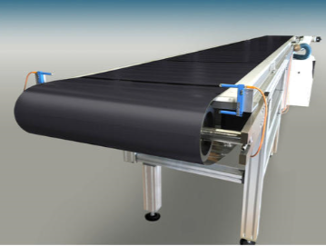
Example Image

    - Palletized Conveyor System – Shall be utilized as high precisions automation for the movement of materials or customer finished goods in, between or at end of manufacturing process steps.
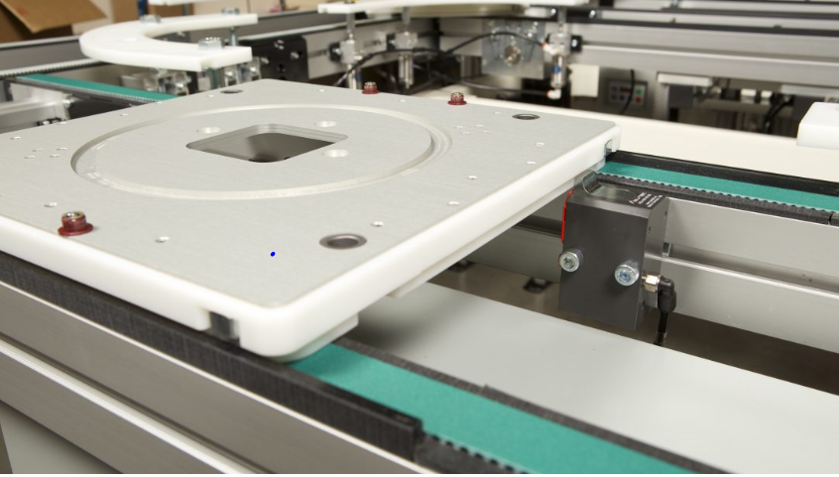
Example Image

    - Conveyor Speed - Conveyor speed and speed adjustability to meet product capacity requirements ranging from 0% to 125% or as required per assembly process design. Note: Recommend internally controlled speed adjustment through PLC Controls and or Frequency Drive within control cabinet
    - Conveyor Precision – Conveyor must meet all specified movement requirements of project for product handling and or placement.
    - Conveyor Size – Size of conveyor to be determined based on product size requirements and optimized for Operator interface and space utilization.
    - Safe design of all manual, motorized or automated conveyance systems shall eliminate the risk to human interface by use of proper guarding and or safe circuit interrupt devices.
    - Tilt table – size and type shall be determined based on GHSP standard equipment used in each facility and meet all safe operating criteria (Pinch Point, Ergonomics, E-Stop, etc.)
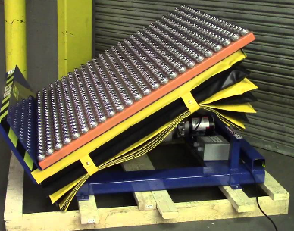
Example Image

    - Rotating Pallet Cart- Shall be used when a lift truck is prohibited to use in the production area. Size and type shall be determined based on GHSP standard equipment used in each facility and meet all safe operating criteria (Pinch Point, Ergonomics, E-Stop, etc.)
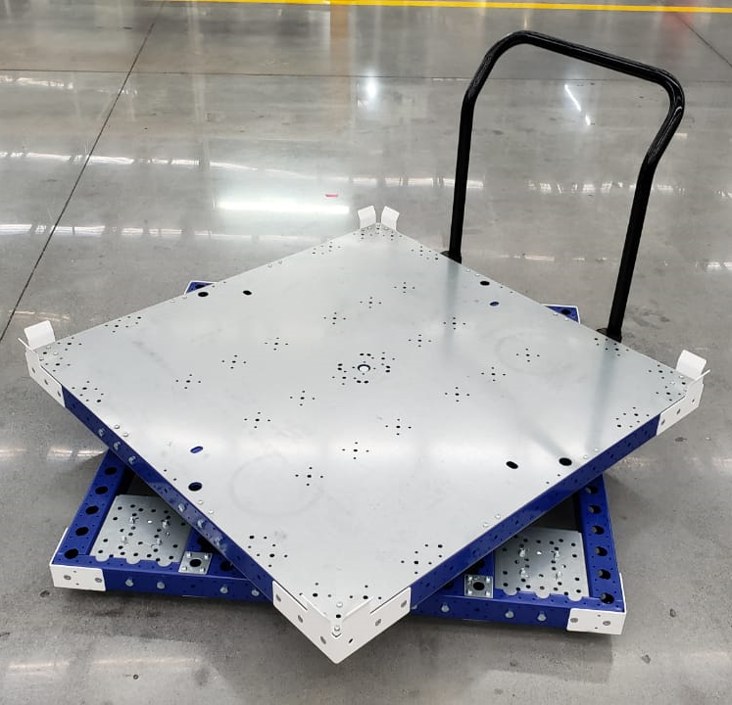
Example Image

  - Installation of conveyors - Conveyors should be mounted in a Movable or Fixed position as required to support the production, installation and ergonomic requirements.
    - Movable position mounting shall be in accordance with the following:
      - Movable adjustable feet as provided in the example below or equivalent approved. (Note: If vibration isolation is required for specialized functions or testing verify capability of mounting method)

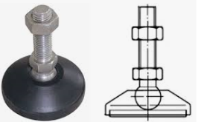

Example Image

    - Caster types (Swivel, Locking and Fixed) as provided in the example below or equivalent approved
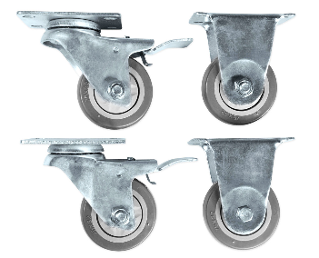
Example Image

      - Fixed Position Mounting of Conveyors should be mounted to floor using the following method of anchoring.
        - Through drilling of anchor location is required to ensure successful use of Type #1 and Type #2 Anchors
        - Height adjustability is required for all anchor types to allow leveling and adjustment of system
        - Type #1 Screw Anchor Condition (See Below): Use of Screw anchors will allow installation of anchor from top down and removal from top.
        - Type #2 Wedge Anchor Condition (See Below): Use of Wedge anchor will allow installation of anchor from top down but removal will require push through downward.
        - Removal and or push through of anchors at end of program and refilling of holes with masonry cement to return floor grade to original state.

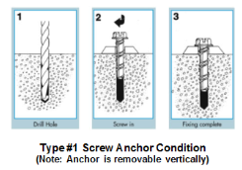

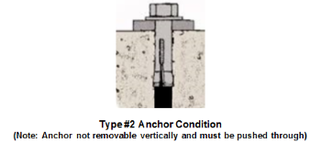
  - Automated Conveyance considerations – Automated conveyance systems shall be the GHSP Standard requirement and first option for all GHSP process development planning as it represents the safest and most efficient manufacturing process.

  - Manual Conveyor considerations – Shall be a secondary option to conveyance when automation is determined to not be feasible through design or cost and by meeting the following criterial acceptably.
    - Weight of product totes or expendable packaging must be determined prior to final selection of conveyance system and evaluated for operator impact utilizing the following: Table #1 – Conveyor Risk Evaluation Matrix

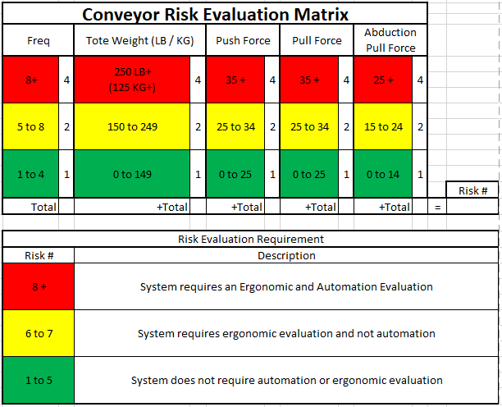

Table #1

      - Manual Conveyor access to handling of product totes or expendable packaging to be evaluated per ergonomic references below to ensure area of application supports work center plan (See EOL Conveyor example in Layout #1 and Layout #2 for Details)
        - (Note: Clearance in ergonomic zones should be minimum 36” Clearance for ease of access and handling technique)

      - Ergonomic Zone – Push – Low Risk area for operator interface with products. Recommended and preferred condition for GHSP personnel manual handling and should be goal for design
      - Ergonomic Zone – Pull – Moderate Risk area for operator interface with products.
      - Ergonomic Zone – Abducted Pull – Elevated Risk area for operator interface with products. Close evaluation required to confirm impact to operators to eliminate risk.

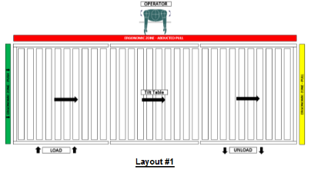
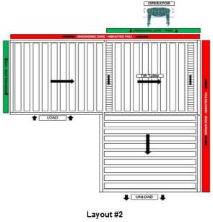

Note: For manual conveyance if evaluation risk to manual operation is determined to be unacceptable then automation of process shall be reevaluated and utilized to eliminate risk regardless of financial impact or design constraints.

  - Environmental Condition or affect: Consideration must be given to the installed environment, affect to human interface including key factors such as:
    - Electrostatic Discharge
    - Temperature/Condensation
    - Excessive Vibration or Shock Loads
    - Hazardous Environment
    - Corrosive Material Exposure
    - Sound

  - Equipment Standard –
    - Preferred EOL & Transfer Conveyor System type and quality:
      - NA Supplier: Kent Material Handling
Contact: Ron Lemaire
Phone: 616-886-3600
Email: rlemairekmh@sbcglobal.net
Product: Omni Metalcraft Chain driven live roller 52”

      - SH Supplier: Misumi
Contact:
Phone:
Email:
Product: Modular System

    - Preferred Palletized Conveyor Systems Type and Quality:
      - NA Supplier: AJACS
Contact: AJACS - Paul Lammers
Phone: 616-333-9567
Email: paul.lammers@ajacs.com
Product: Dorner 2200 Series Precision pallet system.

      - SH Supplier: Bosch
Contact:
Phone:
Email:
Product: Modular

      - Equivalent supplier may be used with submission of proposed new supplier to steering committee and approval by global team for addition to standards.

- Records: N/A

