- Revision Log

Revision Log
Revision Level | Revision Date | Section | Description |  | Revised By
REL | 06/29/2016 | ---- | Initial Release |  | GR
A | 09/06/2017 | 5.1.1 | Updated Module selection based on Extol’s new product introduction. |  | GR
B | 09/24/2019 |  | Mass updates, complete re-write to standard |  | NT
C | 4/27/2022 | 5.5 | Added more information for Laser Welding |  | J. Jakus
D | 12/1/23 | Header | Replaced GHSP logo with newer version |  | B. Balok
Approval: |  | CN: RS |  | MX: BA
 |  | US: JA |  | Other (as req’d): DRW

- Purpose:
  - To define the global standard for the use of Plastic Joining Methods within GHSP manufacturing facilities.

- Scope:
  - This global standard applies to all GHSP manufacturing facilities.

- Definitions:
  - ANSI – American National Standards Institute
    - A private non-profit organization that oversees the development of voluntary consensus standards for products, services, processes, systems, and personnel in the United States.

  - OSHA – Occupation Safety and Health Administration
    - An agency of the United States Department of Labor, whose mission is to assure safe and healthy working conditions for people by setting and enforcing standards.

  - InfraStake
    - A method of joining components together using infrared (IR) light, applied to a molded thermoplastic boss to mechanically retain a mating component. The boss is heated with focused IR energy and then precisely formed with an integrated tool called punch
      - Clamp – Module is positioned over the molded boss. The face of the concentrator clamps parts directly at the stake point.
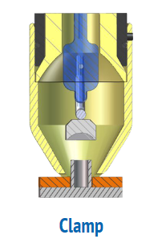
      - Heat – Infrared (IR) lamp is illuminated. Light is focused radially on the plastic boss.
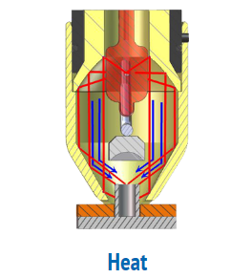
      - Form – IR lamp is switched off and the non-heated punch forms the semi-molten boss into a stake
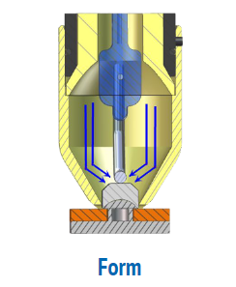
      - Retract – After the plastic has re-solidified, the punch retracts, and the module retracts from the part.
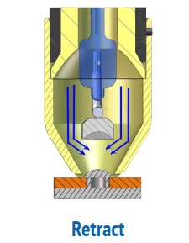
  - Punch
    - Piece of tooling that shapes the boss to a desired shape.

  - Laser Weld
    - A method used to join plastic components by heating the plastic to create a melt zone, using a laser, and then cooling the components to join them together.

- References:
  - CP-WI-MFG-X301 Global Standard Production Equipment Safety, Ergonomic, and Delivery Checklist
  - CP-WI-MFG-X334 Global Standard Strain Gauge
  - Heat Stake Design Specification 7.10.3
  - Job Aids (Operating Standards Job Aids 8.5-Job-Aids-prod-service Global Standards)

- Methods:
  - For all methods of Plastic Joining, if a PCBA is part of the assembly, a Stain Gauge Test must be completed at the equipment supplier.
    - It is recommended to also complete a Thermal Analysis, using an Infrared Camera, to verify PCBA components will not be affected by the joining process (reference Job Aid example).

  - InfraStake Equipment Selection
    - Preferred Brands
Selection outside the preferred brand requires approval by the Advanced Process Engineer and Global Standards Team
      - Extol

    - Setting up the InfraStake process for a new component.
      - Mounting the Modules
        - Each InfraStake module should have a 7/16” (11mm) diameter through-hole in the tooling plate centered over the boss location. This allows for some adjustment of the module relative to the boss.
        - Wherever possible, leave at least 1/8” (or 3mm) of clearance around each InfraStake module to allow the position to be adjusted.
        - Once the InfraStake modules are properly positioned and the machine has produced acceptable parts, the modules can be doweled to the tooling plate.

    - Determining the proper Heat Time
      - Start by making sure the InfraStake module is centered over the boss properly, the cooling air flow rate is set properly, and the punch volume is correct.
      - The ideal heat time strikes a balance between too little heat, which doesn’t melt the boss enough and doesn’t produce a tight stake, and too much heat, which can degrade the plastic, cause the boss to smoke and possibly weaken the stake. Using a heat time that causes the plastic to smoke must be avoided to keep the polished surfaces inside the reflector and the concentrator clean.
      - It’s better to start with a heat time that is too low than one that is too high, so start low.
      - As you stake parts, increase the heat time until the perimeter of the punch contacts the surface of the mating part. This ensures that the punch is extending as far as it can.
      - Once you have found the minimum heat time that produces a good stake, you should increase that heat time by a second or two to determine if you can still produce a good stake without heating the boss so much that it begins to smoke.
      - Setting the heat time a little longer than the minimum time required to produce a good stake (but still short of the time required to make the part smoke) will allow the InfraStake process to accommodate some variation in the part size or the part location in the fixture.

  - Heat Staking Equipment Selection
    - Preferred Brands
Selection outside the preferred brand requires approval by the Advanced Process Engineer and Global Standards Team
      - General Electrical Heating
      - Maxwide

    - Requirements

Specification for Heat Staking
Power | Heat Stake Head Material |  | Head Diameter | Product Application (Post Diameter)
100~150W | Brass/Stainless Steel | Brass: Has good heat conduction effect and relatively short life  Stainless Steel: Has less heat conduction effect and longer life | Ø6~Ø8 | Ø1~Ø3mm
150~200W |  |  | Ø6~Ø8 | Ø3~Ø8mm
200~300W |  |  | Ø8~Ø10 | Ø8~Ø16mm

  - Ultra-Sonic Welding Equipment Selection
    - Preferred Brands
Selection outside the preferred brand requires approval by the Advanced Process Engineer and Global Standards Team
      - Maxwide
      - Branson

    - Requirements

Specifications for Ultra-Sonic Welding
Frequency | Power | Amplitude | Part Melting Point
30KHz | 1000W | 22~26A | ≤220ºC
20KHz | 1800W | 26~32A | ≤180ºC
15KHz | 2600W | 28~34A | ≤160ºC

    - Materials must have compatible melt temps.
    - Energy director design is very critical.
    - If fixture/nest is holding a Class A surface part, fixture/nest material selection is very critical, as to not damage Class A surface during welding process.

  - Laser Welding Equipment Selection
    - Preferred Brands
Selection outside the preferred brand requires approval by the Advanced Process Engineer and Global Standards Team
      - Extol
    - Process options: There are two basic welding styles to choose from, as it pertains to process operation.
      - Weld to a time – Used when final part location is not critical.
        - Weld to a time is exactly that. The part is heated for a certain amount of time (whatever is required to get the rib to melt) and the mating part is pressed into the melted plastic. The mating part is constantly under pressure against the melt rib so as the rib melts the part moves.

      - Weld to a distance – used when final part location is critical.
        - This process is setup the same as above. The difference is where the mating part stops is servo controlled and when the laser shuts off is also controlled by servo position. This is required when the final position of the component is critical. An example would be final position of compliant pins in a motor end cap.
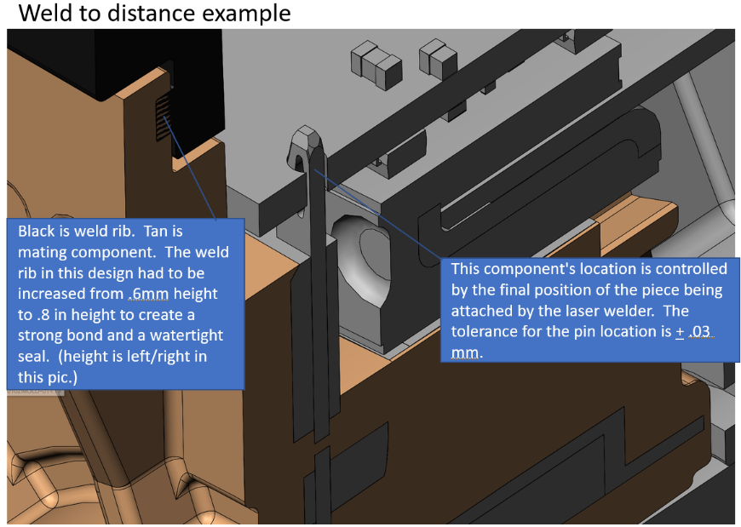

    - Machine design: Questions that should be asked when the machine design is being created.
      - Size of power supply (determined by required cycle time)?
        - Part to part cycle time at the laser should not exceed 70% of required cycle time for the line. This leaves a cushion for process adjustment.

      - Laser path size on part vs laser path size capability?
      - How many laser heads?
      - How many parts are being lasered at once?
      - How is distance part moves controlled?
      - Material being used to provide clamping for that laser will need to shine through
      - Is part clamp servo or pneumatic driven?
      - Laser power supply location?
      - Location of computer that loads program into laser?
      - Location of HMI for the laser machine?

Records: N/A

