- Revision Log

Revision Log
Revision Level | Revision Date | Section | Description |  | Revised By
REL | 06292016 | ---- | Initial Release |  | GR
A | 8/28/19 |  | Mass update, complete re-write to standard |  | NT
B | 12/1/23 |  | Replaced GHSP logo with newer version |  | B. Balok
Approval: |  | CN: RS, FS |  | MX: JH
 |  | US: JA |  | Other (as req’d): DRW

- Purpose:
  - To define the global standard for the use of Riveters within GHSP manufacturing facilities.

- Scope:
  - This global standard applies to all GHSP manufacturing facilities.

- Definitions:
  - ANSI – American National Standards Institute
    - A private non-profit organization that oversees the development of voluntary consensus standards for products, services, processes, systems, and personnel in the United States.

  - OSHA – Occupation Safety and Health Administration
    - An agency of the United States Department of Labor, whose mission is to assure safe and healthy working conditions for people by setting and enforcing standards.

  - Riveting process
    - Riveting process is intended to cold form a metal pin to join materials.

  - Form Tool
    - Piece of tooling that shapes the closing head of the rivet.

  - Stroke
    - Travel distance to form the head of the rivet.

- References:
  - CP-WI-MFG-X301 Global Standard Production Equipment Safety, Ergonomic, and Delivery Checklist
  - Job Aids (Operating Standards Job Aids 8.5-Job-Aids-prod-service Global Standards)

- Method:
  - Orbital Riveter Selection:
    - Preferred Brands
Selection outside the preferred brand requires approval by the Advanced Process Engineer and Global Standards Team
      - BalTec

  - Before setting up for a new riveting job, the following requirements must be determined:
    - Form tool length
      - 100mm length
      - 20mm diameter
      - 5 degree convex to form a flat peen
      - The cup (Rp) and peen length must match to ensure equipment duty cycle (Fig. 2).
    - Stroke distance to end of stroke (dial position)
      - Dwell time is long enough to ensure statistical peened height.
    - Pin design (peened material)
      - Length to be 2.5x Diameter
      - Diameter includes safety factor of shearing of joint
    - Stroke
      - Stroke (H) must be greater than 6mm (Fig.1)

Fig. 1
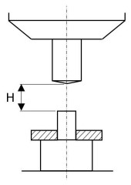

    - The following settings must always be made in the control unit so that the procedure can be interrupted at any time:
      - Insert component
      - Adjust the height of the riveting machine in the stand so that the distance for the form tool to the rivet is smaller than the maximum achievable spindle stroke. If a short cycle time is desired, this distance to the component can be reduced if the necessary distance required to insert the component is maintained.
      - Set the required dimension for the rivet path with the stroke limiting stop. Incrementally lower the stroke limiting ring to determine the correct setting using a test component.
      - At the same time, incrementally adjust the riveting force setting (via pressure regulator) and riveting spindle advance speed (via restrictor valve) to obtain the required results. If the components evidence spreading over the height, the stroke limitation may be an obstacle. In this case, the stoke limiting stop should be set slightly lower than necessary. The actual riveting path is then only limited by the termination of the specified riveting time. If other system parts start oscillating due to resonance by the riveting process, check that the toll is in perfect condition and that the component holder is fastened without any play.

    - Riveting to stoke limiting stop
      - Suitable for components with constant thickness. The necessary riveting path can be finely set by adjusting the stoke limiting stop. The height of the closing head then only spreads by the component height spread value. The riveting time must therefore be enough that the stroke limiting stop is also securely reached. During the “riveting out” on the stoke limiting stop, stress is removed, and the closing head is cleanly smoothed.

Fig. 2
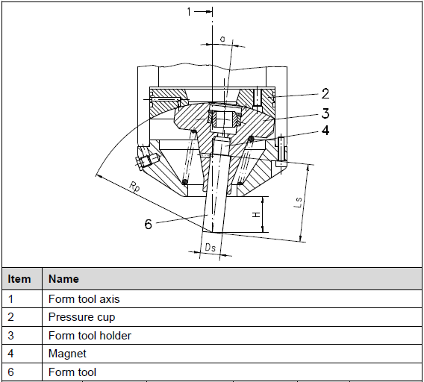

  - Peen Requirements:
    - Material selection preference is a malleable pin.
    - No cracks on perimeter of formed material
    - Peen to be measured from base material to top of peened material (not diameter). Typically measured with a dial indicator (flat-end tip) attached to an H-block.
    - For non-rotational requirements, the preferred profile is Hex (base material hole).
      - This will require sectioning the joint diagonally to ensure pin/peen is formed in hex edges at top of base material.
    - For rotational requirements, the preferred profile is a round hole with a sealing washer (i.e. Honda end-bolt).
      - Pin to have a shoulder step for washer to seal against.

  - Position Feedback:
    - Position feedback is a requirement. It can be achieved with a Linear Position Sensor.
    - Linear Position Sensor Brand Selection
Selection outside the preferred method requires approval by the Advanced Process Engineer and Global Standards Team
- Balluff
- Novotechnik
    - Position limits should be setup from machine HMI

  - Riveting Time:
    - Should be available to control from HMI Riveter screen.

  - Pneumatics:
    - Must use a 2-valve setup
      - 1st Valve uses low pressure (20psi) to allow the rivet head to shift down and touch the top of the rivet and measure
      - If measurement is good, motor turns on and 2nd Valve uses high pressure (80psi) to rivet the pin

  - Lubrication:
    - Use of OEM Lubrication System is required
      - OEM Lubrication System will have a low-level sensor on the reservoir that will stop the riveter if it gets too low. Therefore, it is recommended to add a cycle counter in the PLC to warn operators, via the HMI, that lubrication is getting low and needs to be added to the reservoir, before the lubrication reaches the low-level sensor.

- Records: N/A

