1. **Revision Log**

|  |  |  |  |  |  |
| --- | --- | --- | --- | --- | --- |
| Revision Log | | | | | |
| Revision Level | Revision Date | Section | Description | | Revised By |
| REL | 06292016 | ---- | Initial Release | | GR |
| A | 09062017 | 5.1.2 | Added Standard Thin Client Model | | GR |
|  |  | 5.1.4 | Updated SE DataPro based screenshot | | GR |
| B | 7/29/2019 |  | Mass update, complete re-write to standard | | NT |
| C | 4/18/2023 | 4.0  5.10.3  5.10.5 | Added 4.1 and 4.2 Reference Documents  Remove Thin Client and replaced it with C-more  Updated picture and description of new screen | | N. Taylor |
| D | 12/1/23 | Header | Replaced GHSP logo with newer version | | B. Balok |
|  |  |  |  | |  |
|  |  |  |  | |  |
|  |  |  |  | |  |
| Approval: | | CN: RS | | MX: BA | |
| US: JA | | Other (as req’d): | |

1. **Purpose:** 
   1. To define the global standard for the use of a Takt Time Counter within GHSP manufacturing facilities.
2. **Scope:** 
   1. This global standard applies to all GHSP manufacturing facilities.
3. **Definitions:** 
   1. Takt Time
      1. The average time between the start of production of one unit and the start of production of the next unit, when these production starts are set to match the rate of customer demand**.**
   2. PPPH - Pieces Per Person Hour
      1. The number of parts one operator can produce on its own working on a work center.
   3. Work Center
      1. Designated assembly work cell to manufacture certain component.
   4. OEE - Overall Equipment Effectiveness
      1. A measure of the ability of a piece of equipment or process to consistently produce a part which meets quality standards, at the designed cycle rate without disruption.It incorporates 3 key manufacturing performance elements
         * Equipment Availability (Operating Time / Net Available Time)
         * Performance Efficiency (Total Parts Run X Net Ideal Cycle Time / Operating Time)
         * Quality Rate (Total Parts Run – Total Defects / Total Parts Run)

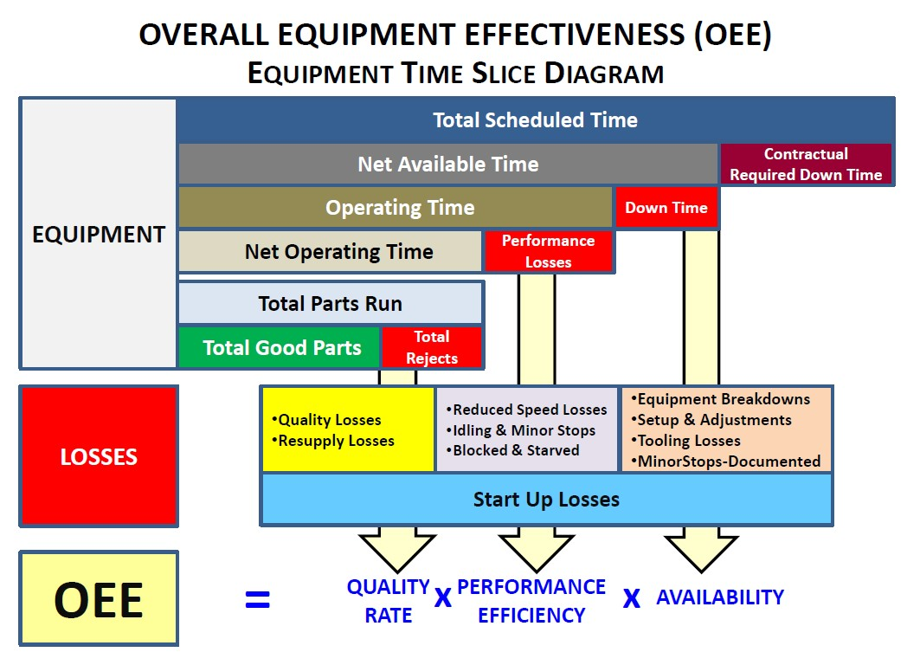

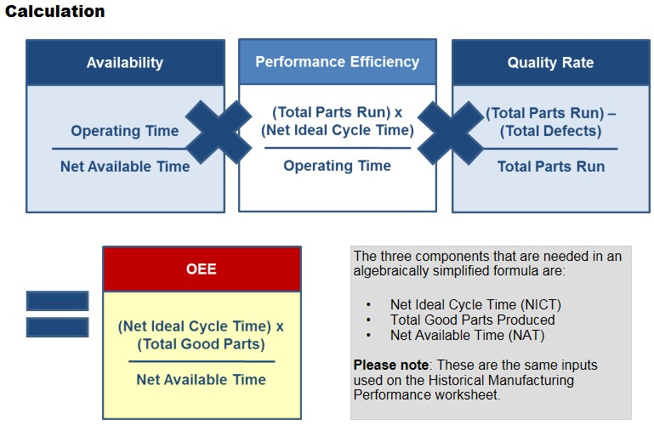

1. **References:**
   1. CP-WI-MFG- X319 Global Standard Electrical Schematics, HMI, and PLC
   2. CP-JA-MFG-X319 HMI Screens
2. **Method:**
   1. Takt time counters will be set up by the established PPPH and the number of associates on the cell, from the machine HMI.
   2. SEDataPro can use this data to display takt count on display.
   3. PLC Tag Syntax will be as follows:

546_5_Pass

Work Center #

Station Number

Status

* 1. PLC will populate tag for the following status
     1. Part pass
     2. Part fail
     3. Trigger
  2. Yellow and red Andon lights will be set at 10% for yellow and 15% for red, + or - the hourly rate.
  3. Takt time counters should be monitored constantly and at a minimum, hourly by the team coordinator and team leader. The production manager will monitor at every opportunity possible.
  4. In the event the light turns yellow the team coordinator should respond, analyze the situation, seek and implement corrective action. (Ahead or behind).
  5. At this point the team coordinator needs to develop a plan to get the team back on track or in the green. This plan could include some of the following options, but not limited to:
     1. Coordinator jumps into the cell to help increase the output.
     2. Coordinator can relieve associates for breaks.
  6. In the event the light turns red, the team coordinator needs to contact the team leader to gain necessary support in addressing performance or technical concerns. The leadership will escalate the issues as necessary, contacting the production manager if no resolution is made to resolve the concerns.
  7. Takt Time Counter Setup
     1. Takt Time Counter Screen Setupshould be done from machine HMI with the following information:
        + **Number of Operators** from Assembly Work Balance
        + **PPPH** from Assembly Work Balance
        + **Reset Time,** for every shift
        + **Start Time,** for every shift
        + **End Time,** for every shift
        + **Break Start Times,** for every break
        + **Break End Times,** for every break
        + **Change to Yellow,** number of parts allowed for Counter to display Yellow
        + **Change to Red,** number of parts allowed for Counter to display Red

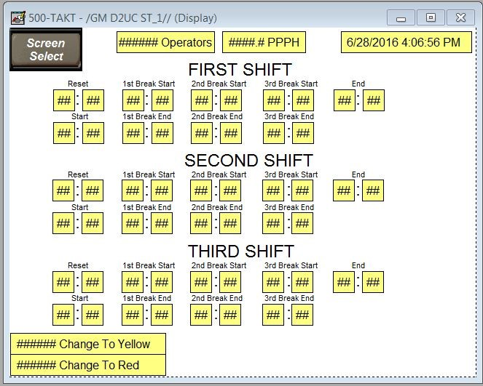

* + 1. Display Brand Selection

*Selection outside the preferred method requires approval by the Advanced Process Engineer and Global Standards Team*

* Any commercially available flat screen TV/Monitor with HDMI input available and a minimum of 720p resolution.
  + 1. Interface Brand Selection

*Selection outside the preferred method requires approval by the Advanced Process Engineer and Global Standards Team*

* + - * C-more EA9-RHMI

* + 1. HMI Takt Time Counter Screen
       - *Station Name*
       - Current Cycle Time
       - *Current Part Number*
       - *Takt Counter*
       - *Actual Counter*

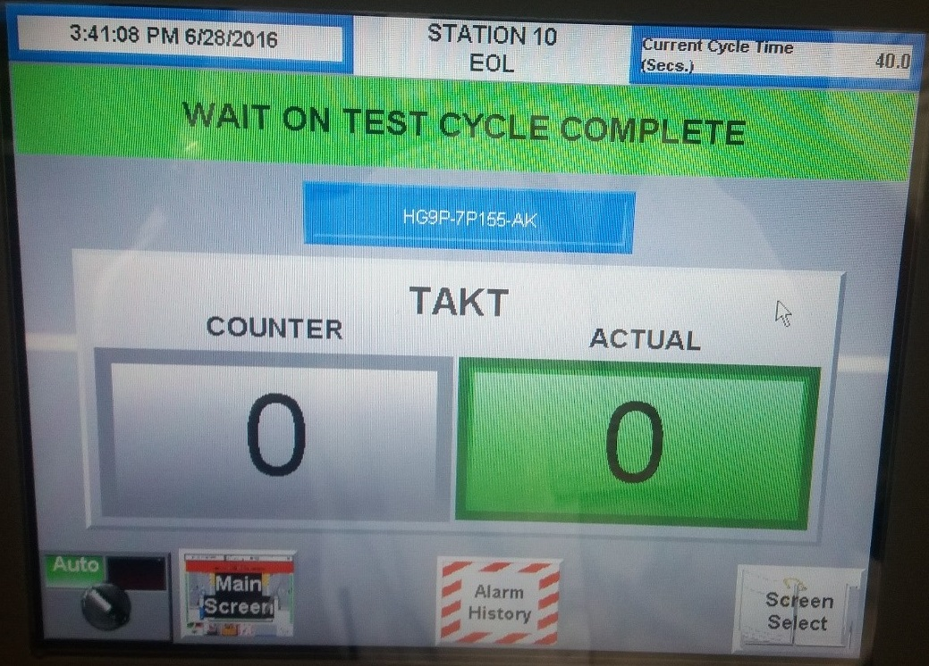

* + 1. North America (Grand Haven, Hart, and Saltillo) Work Center Takt Time Counter Display
       - Work Center Number
       - Hour: Hour of the shift
       - Part Number: The current part number being assembled
       - PPA: Part per array (Electronics assembly only)
       - Expected: The hourly goal at OEE (looking to be 100% because all efficiencies built in)
       - Actual: Good parts made for that hour
       - NG: Failed parts made for that hour
       - Idle: Number of parts that could have been built but were not due to downtime

* + 1. China (Shanghai North and Shanghai South) Work Center Takt Time Counter Display
       - GHSP Logo
       - Total Actual Production Count
       - Work Center #
       - Hourly Takt Time Counter Table
       - OEE

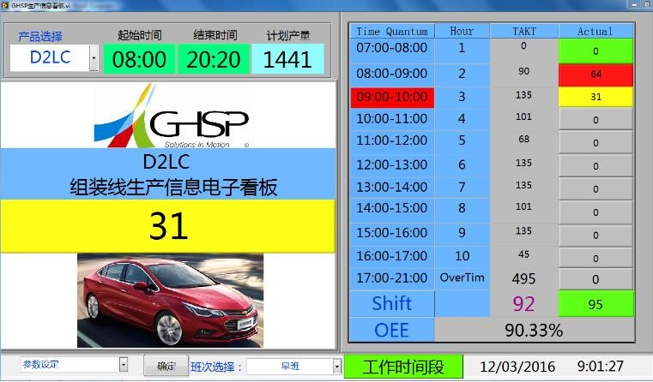

1. **Records:** N/A