Revision Log
Revision Level | Revision Date | Section | Description |  | Revised By
REL | 12/14/2016 | ----- | Release |  | JY
A | 01/04/2018 | 5.14 | Deleted 5.14 Section on Pneumatics and Hydraulics, this information is contained on “CP-WI-MFG-X331-Global-Standard-Pneumatics-and-Hydraulics”  Added reference to Takt Time Counter Standard (Section 5.11.12)  Added audit questions  Updated Color Code (Section 5.7.1)  Updated HMI requirements. Live analog / digital readings. (Section 5.11.7) |  | GR
B | 2/25/2019 | 3.0  3.7.3  5.0 | Many updates – Added revised safety requirements, Adjusted ANSI formula to current use version, added new definitions, Added new reference documents. Removed European safe distance formula |  | MG
C | 11/15/19 |  | Mass update, complete re-write to standard |  | NT
D | 2/28/20 | 3.15  5.3  5.6.1/4.7 | Added Safety PLC definition  Updated requirements  Removed 5.6.1 and reference 4.7 |  | NT
E | 7/23/2020 | 5.11.2 | Added Modbus Gateway requirement for IoT devices if PLC standard is not followed |  | DS
F | 10/12/20 | 5.14 | Added more details for each HMI screen |  | NT
G | 2/26/21 | 5.11.4 | Added PLC Template Storage location and Advance Process Engineer responsibility |  | NT
H | 3/15/21 | 5.5.1  5.6 | Added more information to this statement to help clarify  Updated Safety Circuit Design Schematic |  | NT
I | 10/10/22 | 4.0  5.11  5.12  5.13  5.13.10  5.14  5.15  5.16  5.15.3 | Added Reference 4.9  Moved Section 5.11 to 5.13  Moved Section 5.12 to 5.14  Moved Section 5.13 to 5.15  Added 5.13.10  Removed 5.14 section  Moved Section 5.15 to 5.11  Moved Section 5.16 to 5.12  Added reference to HMI Screens Job Aid |  | N. Taylor
J | 3/3/23 | 5.15.1  5.16 | Add new preferred brand  Added new section |  | N. Taylor
K | 12/1/23 | Header | Replaced GHSP logo with newer version |  | B. Balok
Approval: |  | CN: RS |  | MX: BA
 |  | US: JA |  | Other (as req’d):

  - Purpose:
  - To define the global standard for the use of PLC and HMI Controls within GHSP manufacturing facilities.

- Scope:
  - This global standard applies to all GHSP manufacturing facilities.

- Definitions:
  - ANSI – American National Standards Institute
    - A private non-profit organization that oversees the development of voluntary consensus standards for products, services, processes, systems, and personnel in the United States.

  - NEC – National Electrical Code
    - A regionally adoptable standard for the safe installation of electrical wiring and equipment in the United States. It is part of the National Fire Codes series published by the National Fire Protection Association (NFPA), a private trade association.

  - IEC – International Electrotechnical Commission
    - An international standards organization that prepares and publishes international standards for all electrical, electronic, and related technologies, collectively known as “electrotechnology”.

  - EN
    - European standard, similar to IEC

  - ISO – International Organization for Standardization
    - An international standard-setting body composed of representatives from various national standard organizations.

  - UL – Underwriters Laboratories (formerly)
    - A global safety certification company

  - OSHA – Occupation Safety and Health Administration
    - An agency of the United States Department of Labor, whose mission is to assure safe and healthy working conditions for people by setting and enforcing standards.

  - Safety Circuit System
    - Performance level (PLd) of safety circuit requires safety rated components, that meet or exceed PLd, with redundant mechanical and redundant communication wired and programmed into the machine program function.
    - Consists of the full functional safety system of equipment and its configuration. The safety circuit system is components that prevents or stops movement upon entering or exiting the work area (for example, entry into the light curtain) and cannot be programmed around or mechanically bypassed.

  - Safe Interrupt Devices
    - Refers to items such as:
      - Light Curtains
      - Area Scanners
      - Safety Mats
      - Emergency Stops
      - Gate Switches
      - Safety Relays

  - Control Power Device
    - Master control relay (MCR) or control relay (CR) used for activation of power to all equipment control functions.

  - ESD – Electrostatic Discharge
    - The sudden flow of electricity between two electrically charged objects caused by contact, an electrical short, or dielectric breakdown. The electric charge may be tens of thousands of volts, which can cause permanent damage to components or systems.

  - Electrical Systems
    - Electrical equipment consisting of motors, solenoid operated devices, switches, control stations electrical components and similar contact-making devices, together with the associated wiring.
    - ESD equipment together with the associated wiring.

  - Control Circuits
    - Refers to items such as:
      - Control relays
      - Motor starters
      - PLC systems
      - Safety circuits
      - HMI systems
      - Personal Computers (PC)

  - OCPD – Overcurrent Protection Device
    - A mechanical circuit-breaking device (i.e. fuse, electromechanical circuit breakers, and solid-state power switches).

  - Safety PLC
    - A programmable or configurable automation control device that, when correctly installed, is rated so safety critical applications. Safety PLC’s include additional features and certifications not found in typical PLC’s that increase their reliability to a level where they are acceptable for controlling or disabling hazardous motion. Devices that meet these requirements should be explicitly labeled and marketed as such. A Safety PLC can be integrated into a standard PLC processor, an add-on module for a standard PLC processor, or a standalone unit.

- References:
  - On any point that for which specific provisions are not made in this standard, the most stringent provisions of the National Electric Code (NEC), NFPA 70 and 79, OSHA, state and local codes shall be observed.
  - ANSI B11.19 – 2010 = Performance Requirements for Safeguarding
  - IEC 61131-9 = Programmable Controllers – Part 9: Single-drop Digital Communication Interface for Small Sensors and Actuators (SDCI)
  - IEC 60446 = Basic and Safety Principles for Man-Machine Interface, Marking, and Identification
  - ISO 11898 =BUS-system for Automotive Diagnostic and Flash Applications
  - CP-WI-MFG-X301 Global Standard Production Equipment Safety, Ergonomic, and Delivery Checklist
  - CP-WI-MFG-X323 Global Standard Takt Time Counter Application and Setup
  - CP-WI-MFG-X154-SHS HMI
  - CP-JA-MFG-X319-HMI Screens

- Method:
  - Control Power Device Requirements
    - Control Power Device shall be required for all machines.
    - Control Power Device enables power to all control circuits.
    - Control Power initiation will be required at initial power up, after an E-Stop button has been pressed, or a safety gate has been opened to an automated cell.

  - Safety Circuit System Requirements
    - All components of a GHSP Safety Circuit Systems shall be rated for minimum performance level “D” (PLd). Safety system design must have documented verification of performance level.
      - Reference chart below to cross reference Category to Performance Level to Safety Integrity Level

    - Safety Circuit System shall be a hard-wired interlock system controlled by safety rated devices or Safety PLC.
    - Safety Circuit System shall have dual channel configuration as a redundant countermeasure of system function. (E-stop, Master Safety Relay, or another operator interface device etc.)
    - Safety Circuit System reset functions shall be designed to prevent accidental or intentional tie down of the reset push-button controls.
    - Safety Circuit System reset function shall not create unsafe condition or cause damage to machine or products.

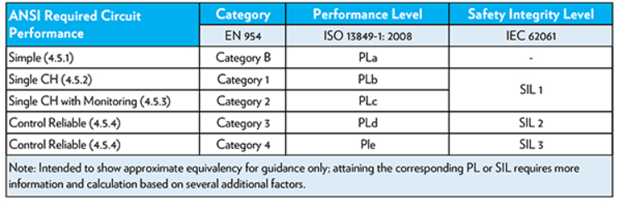

  - Safety PLC Requirements
    - If choosing to use a Safety PLC in place of discrete safety relays, approval by the Plant Technical Services Manager (TSM) is required.
    - Safety PLC shall have access control and/or security requirement enabled on the safety logic, to be acceptable for use.
      - Reset of the safe interrupt device shall only be controlled in the secure logic of the safety PLC

  - Emergency Stop Circuit Requirements
    - Emergency Stop Circuit function shall override all other functions and operations, in all modes.
    - Emergency Stop Circuit shall function by removing power to actuators that cause movement as quickly as possible without creating other hazards. Any motion that may occur as a result of the loss of power must be corrected for with other fail-safe means (i.e. rod locks, shot pins, safety ratchets, energize-to-run brakes, etc.)
      - Selection of the appropriate (safe) stop category is application dependent.
      - Category 2 = Controlled Stop Maintain Power
      - Category 1 = Controlled Stop Remove Power
      - Category 0 = Uncontrolled or Coast to stop

  - Safety Interrupt Device Requirements
    - When in normal production mode, if any hazardous exposure to persons exist, safety interrupt device shall not be controlled or reset through any type of programmable device or automatic function.
    - Safety interrupt device actuation shall not create other hazards (i.e. parts falling from lifts).
    - Interlocked Barrier Guard (Safety Gate)
      - Safety interlock devices are required on all moveable barrier guards in which an associate is required to enter the motion envelope for maintenance purposes.
      - Gate switches with safety rated dual redundant interlock must be installed on each gate. Paired gate switches must be integrated into safety relay input channels.

    - Emergency Stop Device (Push Button, Pull Cable, Deadman Switch, etc.) shall be located within reach at each operator’s control station and at other locations, where emergency shutdown is required.

  - Safety Circuit Design Standard
    - This schematic is for reference to intended circuit design expectation. Actual design schematic shall be verified to meet the intended function as defined within this schematic.

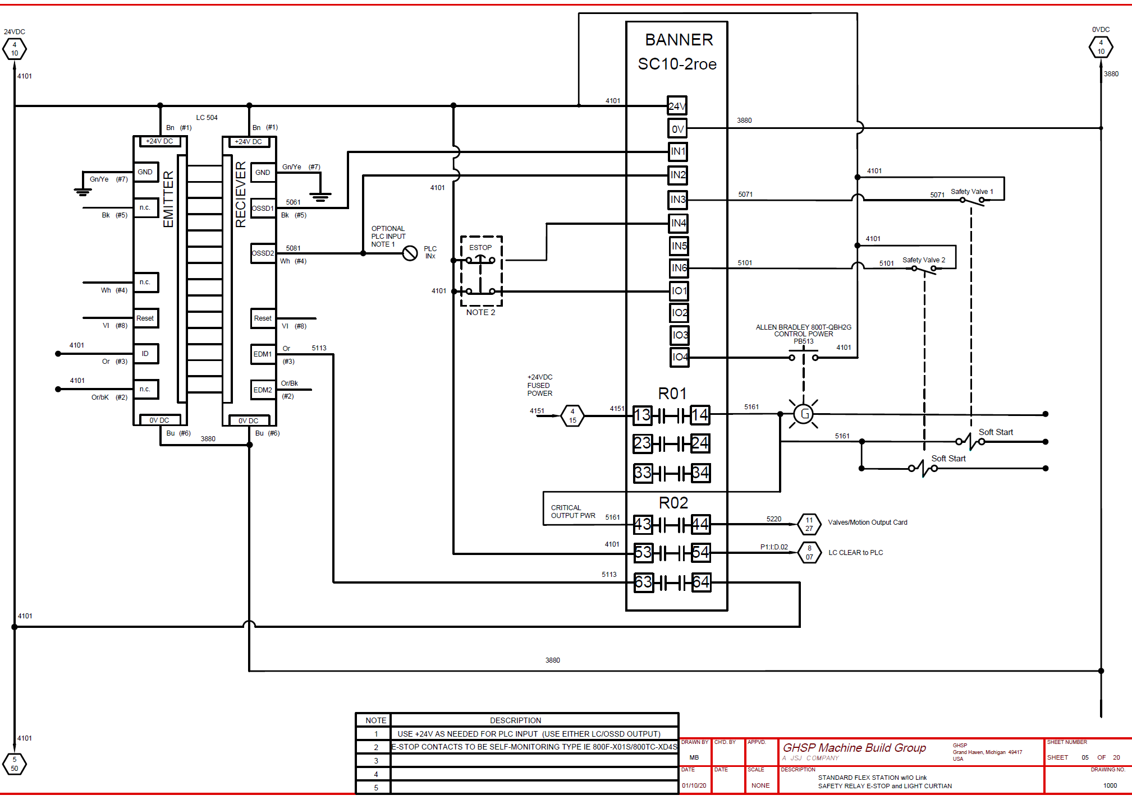
GHSP Safety Circuit Design Schematic

Emergency Stop Circuit Design Schematic

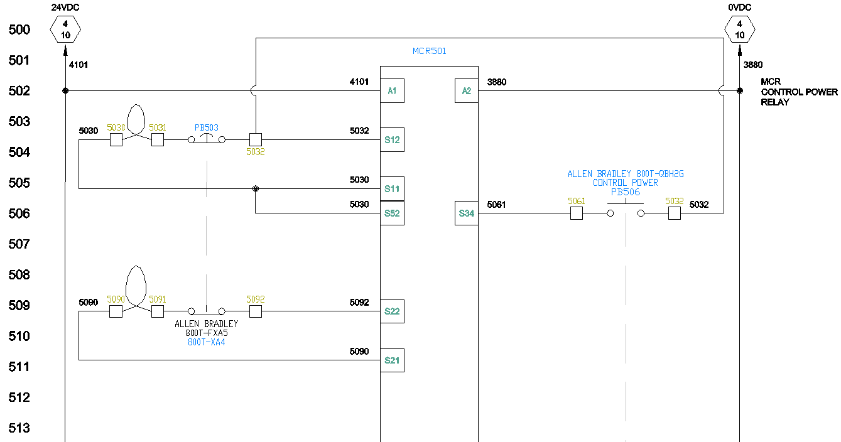
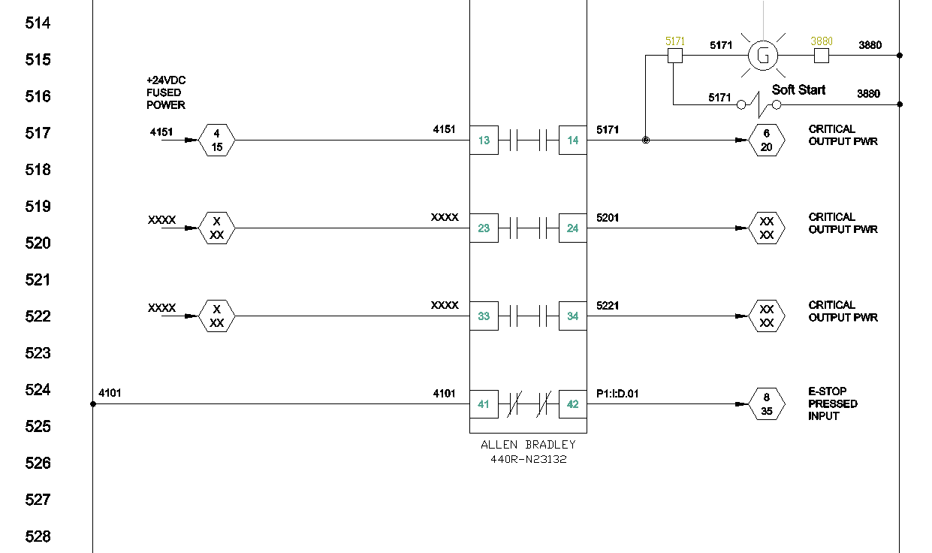

  - Electrical Wiring
    - For Wire Color Codes inside the panel, follow the table below:
 | Voltage | Phases | Line 1 | Line 2 | Line 3 | Neutral | Ground
North America | 120 | 1 | Red | N/A | N/A | White | Green
 | 120/240 | 2 | Red | Black | N/A | White | Green
 | 208 | 3 | Red | Black | Blue | White | Green
 | 480 | 3 | Brown | Orange | Yellow | Grey | Green
China | 220 | 1 | Red | N/A | N/A | Light Blue | Yellow/ | Green
 | 380 | 2 | Yellow | Green | Red | Light Blue | Yellow/ | Green
All | 24 | DC | Blue
 | 24 | Common | Blue
 |  |  | White

      - Yellow shall be used for power not controlled from main disconnect/intrinsic wiring that remain energized when the main disconnect is in the "off" position
      - For communication wires (i.e. CAN, LIN, etc.), wires must be shielded.
    - For more information on color code refer to IEC 60446 and NEC Article 210.5 standards.
    - Conductors must be identified at each termination with a marking that corresponds with the documentation.
    - Identification tags shall be made of oil resistant material. Wrapped adhesive strips shall be a minimum ½” wide. All labels shall be orientated in the same direction, either horizontally left to right or vertically bottom to top.
    - Terminals must be plainly marked to correspond with the wire.
    - Terminals shall be:
      - Numbered in numerical ascending order, starting from top to bottom or from left to right.
      - Terminals of different voltages shall be isolated from each other.
      - Terminal blocks must be wired and mounted so that internal and external wiring does not cross over the terminals.
      - Not more than two conductors may be terminated at each terminal connection.
      - PLC I/O needs to be prewired to a terminal block.
    - All terminal blocks and connections greater than 24 volts must be guarded in such a way to prevent accidental contact using finger-safe design practices.
    - Conductors and cables must be run without splices from terminal to terminal.

  - Control Panel Enclosure Wiring
    - All wiring shall be contained in wiring duct.
      - Exception: Where manufactured cables are installed for specific components, wires may run on the exterior of wire duct in a neat and orderly fashion.
    - Where interlocking of one control panel with another is required, the interlocking conductors must enter and leave each enclosure through a disconnect.
    - Supply circuit and main disconnecting means shall be from a single source, a single disconnecting device must be provided for each individual machine/station.
    - Maximum OCPD shall be 60 Amp. If OCPD over 60 Amp is required, approval is required.
    - An external Ethernet port is required for communication.

  - Cabling Requirements for High-Speed CAN
    - Cables should meet the physical medium requirements specified in table below
      - Belden cable (3084A) meets all these requirements and should be suitable for most applications
    - Cable Lengths:
      - The cabling characteristics and desired bit transmission rate affect the allowable cable length
      - ISO 11898 specifies 40m total cable length with a maximum stub length of 0.3m for a bit rate of 1 Mbps
      - Significantly longer cable lengths may be allowed at lower bit rates, but each node should be analyzed for signal integrity problems

Characteristic | Value
Impedance | 108 Ω minimum, 120 Ω nominal, 132 Ω maximum
Length-related Resistance | 70 mΩ /m nominal
Specific Line Delay | 5 ns/m nominal

  - Cabling Requirements for LIN
    - LIN cables should meet the physical medium requirement of a bus RC time constant of 5 µs.
      - Belden cable (3084A) and other unterminated CAN/Serial quality cables meet these requirements and should be suitable for most applications.
    - Cable Lengths:
      - The maximum allowable cable length is 40m

  - Schematic Requirements
    - All schematics are to be .dwg or .dxf formats.
    - Symbols used on schematics shall meet JIC standards.
    - Drawings must include:
      - Voltage, current draws and power data
      - Transformer voltages and kVA ratings
      - Signal input and output voltages
      - Electrical rating of disconnects, circuit breakers, fuses, and overload devises. (Overload devices may be identified by manufacturer’s number)
      - Wire gauges, insulation, types, and colors

    - On all plugs and receptacles, each pin connection must be shown in the schematic diagram with the proper male/female orientation and identified.

    - Line reference numbers shall be in sequential order on all drawings where the first numbers represent the sheet number and then followed by the line number.
      - Line Numbers
        - Example: 1000

Line Number Increment
Sheet Number

      - Wire Numbers (Non-I/O)
        - Based on Line Reference Number
        - Example: 10000

Wire Number Increment
Line Number

      - Wire Number (I/O)
        - Based on PLC Address
        - Example: 1:I:Data.01

Bit
I/O
Slot

    - All electrical symbols must be shown in the diagram in a de-energized state.
    - Contacts of multi-contact devices (i.e. selector switches and cam switches) must be shown where they are connected in a circuit. A dotted line or a dotted line with a line reference number shall indicate a mechanical connection between the multiple contacts. This does not apply to contacts of control relays, motor starters, or contactors. Charts or diagrams shall be used to indicate the positions of such multi contact devices (see example below).

  - Grounding
    - All equipment shall conform to NFPA 79, Chapter 8 and the applicable portions of NFPA 70 (NEC), Article 250.
    - Equipment is considered effectively grounded when a separate equipment-grounding conductor is required.
    - In all installations of rigid metal conduit, liquid tight flexible conduit, or any other wire ways, a separate equipment-grounding conductor must be installed and bonded at each end.
    - All shielded devices must be grounded in the main electrical enclosure at one end only near the source device unless specified otherwise by the device manufacturer.

  - PLC Requirements/Program Structure
    - Preferred Brands
Selection outside the preferred brand requires approval by the Advanced Process Engineer and Global Standards Team
      - Allen Bradley
        - Motion applications require a motion PLC

    - If Allen Bradley is not available, a Modbus Gateway to connect to SeDataPro is required for IoT connectivity.
      - If the PLC set up is a Modbus TCP Client the same as SeDataPro, required is a RTA Module PN 460MS-NNA1-D or approved similar Modbus TCP Gateway. The Item acts as a Modbus TCP Service that interacts between the two TCP Clients.
      - When working with the SeDataPro and Modbus’s, SeDataPro will always be a TCP Client. Otherwise known as master in the Modbus RTU Protocol.
      - The PLC to Modbus interaction will be 5-digit Modbus addressing. Modbus TCP service also know as a slave in the Modbus RTU Protocol.

    - Revision levels and firmware levels are specific for each GHSP facility. OEM must confirm and get approval from plant Technical Services Manager.
      - Firmware must be Windows 10 compatible
      - It is recommended to add a text indicator on the HMI “Machine Information” screen to note revision/firmware level

    - All PLC programs must start with the GHSP Standard “PLC Template” (located in Mainstay 8.5>Job Aids).
      - OEM shall request template from Advance Process Engineer

    - Use descriptive labels on Inputs/Outputs (i.e. Part Clamped Local:I:Data.1.00, Clamp Part Local:O:Data.1.00)
    - PLC Routines are to be separated into operations (i.e. Faults, Map_Inputs, Map_Outputs, GHSP_Sequence).
    - For each program, routines must be called out every scan in the Main Routine.
    - Utilizing sequential logic/sequencers are strongly encouraged for PLC programming.
    - All tags shall be cleared after every cycle.
    - For multi-station robot managed cells:
      - The robot program shall be written in a manner where the robot will continue to process parts out of the cell, even if no new parts are being introduced to the cell. Then as new parts are introduced, the robot can resume normal flow and start processing the new parts.

  - PLC and HMI Back Up Programs
    - PLC/HMI running programs shall be saved before any changes are made.
    - PLC and HMI program backups should be performed, at a minimum, annually.

  - HMI Requirements/Program Structure
    - Preferred Brands
Selection outside the preferred brand requires approval by the Advanced Process Engineer and Global Standards Team
      - Allen Bradley – North America
      - MCGS – China

    - For Shanghai HMI’s, reference CP-WI-MFG-X154-SHS HMI
    - HMI Programming:
      - Reference CP-JA-MFG-X319-HMI Screens, which covers:
        - Default HMI screens all machines must have
        - HMI screens specific to multi-station machines
        - HMI screens specific to single station machines
        - HMI screens specific to process (i.e. screw driving, InfraStaking, EOL’s)

  - RFID Badge Scanning
    - Preferred Brands
Selection outside the preferred brand requires approval by the Advanced Process Engineer and Global Standards Team
      - Rockwell Automation-pcProx Plus for HMI
        - Note: Black or Grey surface mount version recommended

    - Recommended to use a USB splitter on the HMI to allow you to plug the RFID Scanner into it and then other devices when they are needed.
    - Reference the “Badge Manager” section in the CP-JA-MFG-X319-HMI Screens document.

- Records:
  - HMI and PLC programs to be included in the Assembly Equipment Manual.
    - Once in production, anytime a change to the HMI or PLC program is made, that affects the process, a PCR must be written and approved.
  - All HMI and PLC programs must be stored on the facility server.
    - Old revision must be stored with an updated file name that includes the year, month, day, and original file name. For example: Year.Month.Day.XXXX or XXXX.Month.Day.Year
      - We shall not rely on the Windows “Date Modified” column on the file manager screen as our indication for latest revision.

