0.0 Revision Log

Revision Log
Revision Level | Revision Date | Section | Description |  | Revised By
REL | 06242016 | ---- | Initial Release |  | PZ
A | 5/17/19 |  | Mass update, complete re-write to standard |  | NT
B | 10/27/21 | 5.1.2 | Added HSC device recommendations and Fig. 1 picture |  | NT
C | 12/1/23 | Header | Replaced GHSP logo with newer version |  | BB
Approval: |  | CN: RS |  | MX: DM
 |  | US: JA |  | Other (as req’d): DRW

- Purpose:
  - To define the global standard for the use of Load Cells in GHSP manufacturing facilities.

- Scope:
  - This global standard applies to all mass production processes at all GHSP manufacturing facilities.

- Definitions:
  - Load Cell
    - A transducer that is used to create an electrical signal whose magnitude is directly proportional to the force being measured.
  - PM – Preventive Maintenance
    - A schedule of planned maintenance actions aimed at the prevention of breakdowns and failures.

- References:
  - CP-WI-MFG-X301 Global Standard Production Equipment Safety, Ergonomic, and Delivery Checklist

- Method:
  - Load Cell Selection
    - Preferred Brands
Selection outside the preferred brand requires approval by the Advanced Process Engineer and Global Standards Team
- Kistler Instruments Load Cells
- Futek Instruments Load Cells
- RST Sensor Load Cells

    - Load Cell Measurement Requirements
- Determined by Manufacturing based on Customer Specifications
- To gain measurement time during short install distances when needing to know force vs distance, recommended preferred method is to add a Hydraulic Speed Controller (HSC).
  - Preferred Brand
    - Mindman

  - HSC to be installed in line with cylinder (Fig. 1)
  - This device eliminates the need for a servo or the need for a data collection device (i.e. SigPOD or Kistler)

Fig. 1
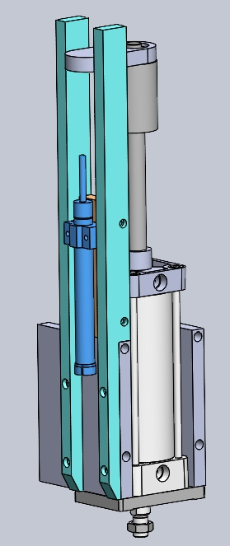

    - Communication
- EtherNet/IP

    - Cables
- Proper cables (i.e. shielded) are to be used to eliminate noise issues
- Cables shall not be routed next to High Voltage electrical wires
- Cables shall not be wired directly to the electrical panel. Rather a “pigtail” (i.e. quick disconnect) should be used, with the connection location placed somewhere easily accessible, to reduce change out downtime.

  - Calibration
    - An annual calibration PM needs to be entered in the PM database.

- Records: N/A

