- Revision Log

Revision Log
Revision Level | Revision Date | Section | Description |  | Revised By
--- | 6/1/16 | ---- | Initial draft |  | NT
REL | 11/22/16 | ---- | Revised draft; initial release |  | NT
A | 2/3/17 |  | Updated NA standard rack details and added Shanghai North and South standard rack info |  | NT
B | 3/22/17 | 6.0 | Updated picture to include front view |  | NT
C | 5/4/17 | --- | Added Audit Questions |  | NT
D | 5/23/17 | 6.0 | Updated picture to correct dimensions |  | NT
E | 5/21/18 | 4.0, 5.0, 6.0, Fig. 1, Fig. 2 | Many updates, including changes to Fig. 1 and adding Fig.2 |  | NT
F | 4/26/19 |  | Mass update, complete re-write to standard |  | NT
G | 12/1/2023 |  | Replaced GHSP logo with newer version |  | BB
Approval: |  | CN: RS,FS |  | MX: JH
 |  | US: JA |  | Other (as req’d): DRW

- Purpose:
  - To define the global standard for the use of Material Racks with GHSP manufacturing facilities.

- Scope:
  - This global standard applies to all GHSP manufacturing facilities.

- Definitions: N/A

- References:
  - CP-WI-MFG-X301-Global Production Equipment Safety, Ergonomic, and Delivery Checklist
  - PD-FORM-MFG-121-NA Equipment RFQ

- Method:
  - The assigned Advanced Process Engineer is responsible for procuring production assembly equipment, which includes material racks.
    - United States: Racks should include 3 adjustable gravity conveyors with side guard rails and an end stop on both ends. Racks can be customized (i.e. ordered with only 2 conveyors, different widths or lengths) if need be, based on application.
- Frame:
  - Should be constructed of 1.5” x 1.5” extruded aluminum (i.e. 80/20 1515 Series or similar) or metal tube covered by plastic (i.e. Creform)
  - An easily removeable guard should be under each conveyor, except bottom conveyor, to prevent debris from falling into the totes below.
    - For applications in an ESD area, appropriate ESD safe material is to be used.

- Conveyor
  - Conveyor width should be 1” wider than standard tote sizes.
  - Conveyor rollers to be mid-set in the rails, using the rails as edge guides.
  - 0.9” diameter rollers are recommended, with a 1.5” on center spacing.

- Casters:
  - Front: 4” Fixed Plate
  - Back: 4” Swivel Plate with Brake

- Preferred Suppliers:
  - Equipment OEM
  - Rapid Control Service, Inc.
  - Sun Down Sheet Metal, Inc.

    - Saltillo: Racks should include 3 adjustable gravity conveyors with side guard rails and an end stop on both ends. Racks can be customized (i.e. ordered with only 2 conveyors, different widths or lengths) if need be, based on application.
- Frame:
  - Metal tube covered by plastic (i.e. Creform)

- Preferred Supplier:
  - Racks built by the plant maintenance area

    - Shanghai-South:
- Frame:
  - Metal tube covered by plastic (i.e. Creform)

- Type:
  - Customize according to site requirements

- Preferred Supplier:
  - Item
  - Xuying

    - Shanghai-North: Below is a list of the 2 recommended widths. Both widths can be ordered with 3 of 4 conveyors.
- Frame:
  - Type-1 = 680mm x 1500mm (WxL)
  - Type-2 = 480mm x 1500mm (WxL)

- Preferred Supplier:
  - Racks to be built by assembly line supplier

    - Locking nuts must be used for the assembly material racks.
    - All 4 corners of each gravity conveyor must be securely connected to the frame.

  - Ergonomic Requirements:
    - There are to be no sharp edges or points on the racks.
      - Recommend using Conveyor Guard End Cap (352ECS) on load and unload ends of the conveyor
    - The Ideal Picking Zone (Fig. 1) for parts should be between vertical heights of 25in-52in (.64m-1.32m), with the tote opening tilted towards the operator, to create a reach-in motion, not a reach over and then in motion. These dimensions are based upon NIOSH recommendations using data of 95th percentile for males and 5th percentile for females.
    - Parts/Racks need to be located so that twisting at the trunk, by the operator, is minimal.
    - Hand-hold height (the point at which the operator grasps the tote or, if using 2 hands, the midpoint of the grasps) should not exceed 64in (1.63m).
    - It is recommended that the top conveyor is to be used for empty totes/boxes only. In this case, hand-hold height should not exceed 72in (1.83m).
    - If totes/boxes weight more than 35lbs (13.88kg), a 2-person lift or approval from the plant Safety Engineer and Packaging Engineer will be required.
      - See Fig. 2 below for recommended lifting zones.

    - Conveyors will be labeled with part numbers and min/max quantity labels for totes/boxes. The minimum quantity will be established to make sure that the operator does not run out of parts. The max quantity will be established to make sure that parts do not fall off the back of the roller conveyor.

Fig.1 (Ideal Picking Zone reference only, not a representation of material rack design) 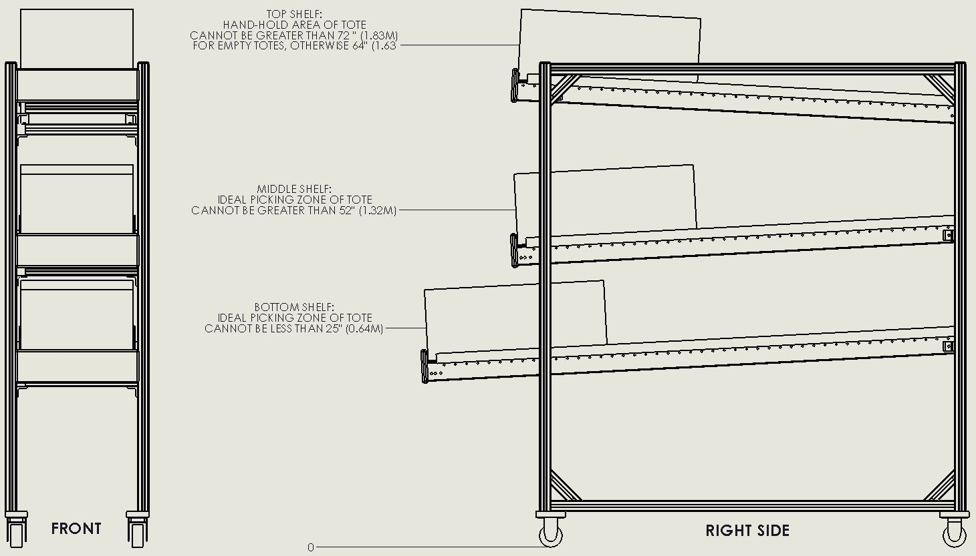
Fig.2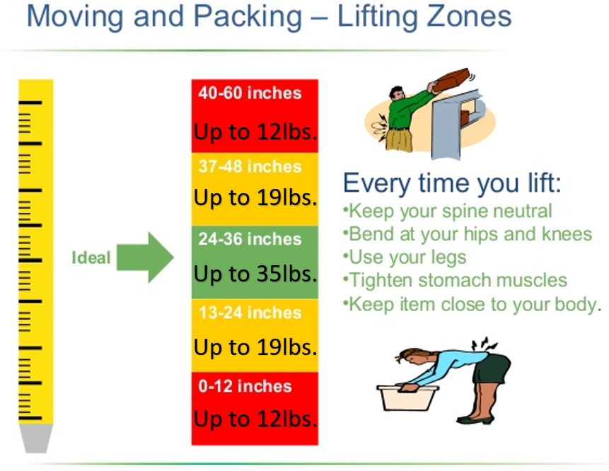

- Records: N/A

