- Revision Log

Revision Log
Revision Level | Revision Date | Section | Description |  | Revised By
REL | 05182016 | ---- | Initial Release |  | OC / GK
A | 20180427 |  | Multiple updates |  | GR
B | 4/26/19 |  | Mass update, complete re-write to standard |  | NT
C | 11/5/20 | 5.1.9 | Add Dycem Clean room mats as an alternative |  | DM
D | 12/1/2023 | Header | Replaced GHSP logo with newer version |  | BB
Approval: |  | CN: RS,FS |  | MX: JH
 |  | US: JA |  | Other (as req’d): DRW

- Purpose:
  - To define the global standard for the use of Clean Rooms (ISO 4 to ISO 7) within GHSP manufacturing facilities.

- Scope:
  - This global standard applies to all GHSP manufacturing facilities.

- Definitions:
  - Clean Room
    - A room that is certified to an ISO level (ex. ISO 7) that is maintained to this certification level. Only building material that are non-dust generating can be used in its construction. No manufacturing equipment or material used that generates dust can be used in this space without containing the dust generator in the area.

  - ISO - International Organization for Standardization
    - The primary authority for clean room classifications.

- References:
  - ISO-14644-1 Classification of Air Cleanliness
  - ISO-14644-2 Clean Room Testing for Compliance
  - ISO-14644-3 Methods for Evaluating & Measuring Clean Rooms & Associated Controlled Environment
  - ISO-14644-4 Clean Room Design, Construction, and Start-Up
  - ISO-14644-5 Clean Room Operations
  - IA-FORM-MFG-X03 US ESD Audit Checklist

- Method:
  - General Guidelines
    - Product requirements define cleanliness. Product design determines the level of cleanliness of the manufacturing space or customer requirements and/or perception (ex. will the product fail if the size and/or number of particulates are too great and will inhibit function of the product?).
    - Electronic and Mechatronic products must be assembled away from any other process that can cause contamination. If that is not possible, the area must be isolated by walls or PVC cleanroom curtains (a room within a room). When necessary, the construction must be made of materials approved for a certified clean room design. It is recommended to follow ISO 14644 guidelines for ISO Class 7 (10,000).

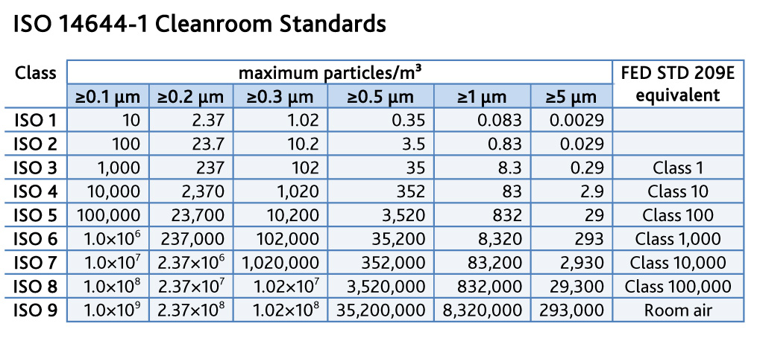

    - Temperature should be provided for:
- Manufacturing processes
- Equipment and materials
- The reduction of electrostatic charges
- Personnel comfort
    - The locations at which temperatures are required to be measured, should follow the ISO standard.
    - Temperature levels for personnel comfort should be defined for these specific installations.
    - Positive pressure atmosphere, if required, should between 5 Pa to 20 Pa to allow doors to be opened and to avoid unintended cross-flows due to turbulence. Comprising of: circulating air, HVAC makeup air and exhaust spec’d for air turns and filter size/style.
    - If required by product design or customer requirements, entrances into the clean room production area may have an air shower entrance with two doors.
      - With a 2 door system, both doors cannot be opened at the same time.
    - Tack mats, shoes covers, or equipment designed to clean the soles of shoes must be installed at all entrances.
    - Dycem Clean Room Mats can be used as an option for clean room entrances.
      - Choosing the right size for Dycem Clean Room Mats must consider:
        - Level of Contaminants
          - Number of operators and carts
          - How often wet cleaning takes place
          - Physical size available

        - For effective decontamination, at least 3 meters for Dycem is recommended to provide a sufficient surface area to allow for six foot falls (three of each foot) or three full wheel rotations before reaching critical areas.
        - For proper Dycem Clean Room Mats you should contact your direct vendor at https://dycemusa.com/contact/

    - A clean room dressing room maybe needed for employees to put on their protective garments.
    - Soft Wall clean rooms to have the walls cleaned by approved methods at least once per year, or more if deemed necessary.
    - PM should set up for the filters and pressure sensors in the HVAC systems.
    - Yearly certification done by third party to verify the air quality.
    - Personal fans ARE NOT allowed in a Clean Rooms.

  - Layered approach to no cardboard:
    - No cardboard allowed in the immediate electronic board assembly area.
    - Chip pads or wax coated corrugated cardboard will be allowed.
    - Components should be delivered to the work center sealed in plastic bags or ESD safe bins.
    - Boxes need to be opened outside of the clean room to eliminate cardboard dust from cutting the boxes open.

  - Clothing/Gowning (for ISO Class 7 and below)
    - Hair Net is required.
    - Beard Net is required with any facial hair.
    - Frock/Lab Coat is required.
      - Where defined by Engineering or Customer Requirements, static-dissipative thread fabrics should be used
    - Gloves are optional, based on Engineering/Customer Cleanliness Requirements, per station.
    - It is recommeded a mirror be located where people will be gowning and apply hair/beard nets, to verify gowns and nets are on correctly.

  - Clean Room Entry
    - All supplies must enter the clean room through the material pass-through doors.
    - Unbox equipment, parts, etc. and remove packaging before bringing them into the clean room.
    - Keep wood, pencils, cardboard, non-cleanroom rated paper, or materials that generate particulates out of the clean room.

  - Clean Room Activity
    - Activity - Do not:
- run or make fast movements
- touch, rub, or scratch scalp, skin, hair, or eyes
- write on walls, gloves, equipment, or garments
- use duct tape
- sand, drill, file, or weld

    - Apparel - Do not:
- remove any piece of clean room apparel
- remove articles from underneath clean room garment
- wear contaminated, soiled, or torn cleanroom garments
- wear any jewelry if it will compromise safety attire or interfere with clean room activities
- do not consume food or drink
- do not use tobacco

- Records: N/A

